# Equity profile United States

This analysis is based on a methodology developed from 2010 and 2020[1] [2] [3].It uses international data sources to identify global wellbeing references, identifies the levels replicable to all and estimates the deficit from those by country, time-period, sex and age group.

This new way of looking at a country’s performance on ecology, economy and wellbeing within the feasible and sustainable parameters, can stimulate further subnational analysis and more precise and useful elements to drive local, national and international policies towards equity.

**Methodology**

The only global health objective agreed by all countries is the constitution of the World Health Organization, which aims at the “*best feasible level of health for all*”. With international data - from 1960-2020- we identified such “best feasible level of health” and selected countries with good health (life expectancy above world average) with “globally feasible” economic (GDP and wealth pcy < world average) and ecologic conditions (bio capacity < world average and ecological and carbon footprint < sustainable threshold) sustainable in time, hence safeguarding intergenerational equity.

Using those *healthy, replicable and sustainable* (HRS) models[4], we adjusted mortality rates by age and sex published by the UN Population Division every five years. We call the excess mortality above that from the HRS models, the *burden of health inequity*. The analysis also allows setting the “*dignity threshold*” (below which no country has achieved that best feasible health) and the “*upper threshold*” (above which wellbeing does not improve). Those thresholds frame the *equity curve* between both and the level of *redistribution required* for those under the dignity threshold (in need of net support) or from those above the upper threshold (ethically responsible for net contribution).

Taking into account the negative impact on third countries by excess income pc or excess carbon emissions pc, we estimated the *Sustainable and Equitable Wellbeing (SEW) Index[5].* The methodology we hereby propose challenges XXth century concepts such as high income-development models, constant GDP growth, poverty, ODA and the human development index. The hereby suggested “*equity lenses*” provide a useful tool to identify *alternative wellbeing models*, subnational analysis and policies towards territorial and fiscal equity and individual and collective conscious responsibility based on the ethical principle of equity.

Figure 1 Global equity curve between dignity and excess thresholds allowing best feasible level of health for all



Our analysis reveals that the best levels of wellbeing (through proxy life expectancy) can be achieved within the equity curve, which accommodates all countries, and within them, all peoples above the dignity threshold and below the upper threshold. In 2020 the equity scope was from 4,000-18,000 GDP pc CV, below which no country could achieve best feasible levels of health (right to health) and above which wellbeing did not improve any further while no country was ecologically sustainable and the excess income prevented others from the right to health.

## Comparison with neighbour countries and other with similar natural and economic means

The first attempt to assess a situation is to compare with others in similar situations and identify the potential to improve. The following table compare the ecological, economic and wellbeing indicators (including the burden of health inequity) with the closes countries (geographically and with historical and cultural links) to United States:

Table 1 Comparative analysis with neighbouring countries



The above table shows how United States has a bio capacity between the two neighbour countries, Canada and Mexico, and economic power (estimated though GDP CV) between the two. It uses natural resources (measured by the ecological footprint) at a rate lower than both. The level of life expectancy at birth is between the two neighbour countries.

Table 2 Comparative analysis with countries of similar natural and economic means



The countries with closest levels of GDP CV pcy (proxy of average income, subject to subnational inequities) and bio capacity pcy, are Ireland and Denmark. United States has a life expectancy at birth lower than both mentioned countries.

Table 3 Comparative analysis with the international average and the HRS reference indicators



The table above shows the relation of the ecologic, economic and health main indicators of United States with the international average and with the Healthy-Replicable-Sustainable standards.

It reveals that the bio capacity of United States is 224% of the world average, hence being non replicable at global level. The ecological footprint of United States is 69% of the international average and 118% of the recycling threshold, hence ecologically non-sustainable. As regards the balance with its own natural resources, the ecological footprint of United States is 53% of its average bio capacity pcy, therefore it is sustainable at national level. The level of CO2 emissions pcy is 331% of the international level and 850% of the ethical threshold, therefore contributing to global warming.

As regards the economic indicators, United Statess GDP CV pc is 563% of the international average (hence economically non replicable) and 1577% of the HRS reference. Its cumulative wealth pcy is 677% of the international average and 2369% of the HRS reference.

In terms of health, the life expectancy in United States is 6.06 years above the international average (6.41 in women and 5.72 above in men) and 2.00 years above the HRS level (1.12 above in women and 2.87 above in men) with a proportional sex difference of 6.38%, higher than the world’s average.

## HRS indicators 1961-2020

### Ecologic indicators:

The following graphs represent the annual average levels of the nature’s recycling capacity in hectares pcy (bio capacity), the rate at which such resources are used (ecological footprint) and the level of CO2 emissions pcy in United States. These indicators are compared with the international average and the recycling threshold above which the level is not replicable (bio capacity pcy) or not sustainable (ecological and carbon footprints), leading to nature’s depletion and (in the case of CO2 emissions) global warming.

Figure 2 Bio capacity pcy vs. world average 1961-2020



Figure 3 Ecological footprint pcy vs world average and recycling threshold 1961-2020



Figure 4 CO2 emissions pcy vs world average and ethical threshold 1960-2020



As the graphs above show, United States has a bio capacity pcy non replicable at global level, regarding its ecological footprint it is ecologically non-sustainable at global level and its present level of CO2 emissions is contributing to global warming above 1.5 degrees during this century. The use of natural resources is however sustainable at national level given its high bio capacity pc.

### Economic indicators:

The graphs below the annual average levels of economic flows measured by GDP constant value (CV) and Purchasing Power Parity (PPP) pcy.

Figure GDP CV pcy vs international average, dignity and excess thresholds 1961-2020



The above figure shows the trend of the GDP CV pc in United States in relation with the levels of the international average, the HRS reference (below which no country in 60 years has achieved the feasible best level of health for all –hence named “dignity threshold”-) and the upper limit (symmetrical level above which wellbeing does not increase further while it hampers others’ reach of the dignity level and is not compatible with respecting planetary boundaries –hence named “excess threshold”-). The overall GDP of United States is $20086126631201, *24.5843%* of the world’s GDP (while being *4.3255%* of the world’s population), which translates in GDP pc $61668pcy, as mentioned above, 563% of the international average and 1577% of the HRS reference.

Figure 6 GDP PPP pcy vs equity thresholds 1986-2020



The graphs above show that the level of GDP CV and PPP pcy during the study period (1961-2020 for CV and 2000-2020 for PPP) in United States is non replicable globally considering the level of global economic resources.

Figure 7 ODA flow pcy (provided/received) 1961-2020



Figure Required ethical redistribution 1961-2020



Figure ODA as percentage of required ethical redistribution



The figure above shows the levels of ODA pcy. In relation with contribution to required international redistribution of $ -10462 pcy to enable global economic and healh equity, United States contributed with an annual average during 2016-2020 of $ -99.72 pcy ,0.95% of the level required while recived considerable annual support from the EU.

### Health indicators:

The graphs below represent the level of life expectancy at birth evolving over time from 1961 until 2020, and comparing the levels of United States with those of the international average and the HRS reference.

Figure 10 Life expectancy by sex and time periods vs. international average and HRS reference, 1961-2020



The graph above shows the relation of life expectancy in United States, between 1961-2020; with the international average and the HRS reference. Such gap is today 6.41 above the international average in women and 5.72 above in men, and 1.12 years above in women and 2.87 above in men than the HRS reference.

Figure 11 Healthy life expectancy vs international average and HRS standard, 1996-2020



The estimates of the World Health Organization, of the healthy life expectancy (HALE), accounting for disability as well, reflect that the trend of HALE in United States, in relation with the international and HRS average. At present, the estimated level of healthy life expectancy in United States is 104% of the international average and 99% of the HRS level.

Figure 12 Life expectancy gap by sex, vs international average 1961-2020



Figure 13 LE % lower in men than in women, vs international average 1961-2020



What the graphs above show is the trend in the difference between life expectancy between men and women in United States. It stands today at 5.18 years lower in men, which is higher than the world % difference (at present some 6%).

## Burden of health inequity

### Burden vs. HRS reference:

As mentioned in the methodology, we selected the country (Sri Lanka) which has maintained the ecological sustainability, economic replicability and the health above average as the reference to compare mortality rates by sex, age group and time period and estimated, through adjust mortality rates the excess mortality from those feasible standards.

Figure 14 nBHiE ref HRS by sex and time period 1961-2020



The above graph represents the excess mortality in United States, (with 1577% GDP CV pc of the HRS reference), that is, the net burden of health inequity (nBHiE). It has increased in the last 20 years, especially in women and adds up to almost 100,000 excess deaths in relation to the HRS reference.

Figure nBHiE by sex and age group 2016-2020



The figure above shows how the excess mortality takes place mainly in women from 25 to 65 years old, and to a lesser degree in men of 20 to 35 years.men older than 90 years.

Figure 16 rBHiE by sex and time period vs international average, 1961-2020



The share of all deaths that was in excess in United States when compared with the feasible mortality rates in the HRS reference, allows comparison in time and with other countries and the international reference as it is not influenced by the size and/or shape of the demographic pyramid. It increased in the last two decades in women to 5.71% at present and in the last 5 years to 1.13% in men.

Figure rBHiE by sex and age group 2016-2020



The figure above shows how the excess mortality affects mainly women from 25 to 65 years of age reaching 40% of deaths in the 39-40 year old group, and to a lesser degree men from 20 to 35 years of age with around 20% of all deaths.

### Burden vs. best SEW reference:

While the minimum aspiration of feasible health for all is the HRS reference, which uses 40% of the world’s average resources per person, the comparison with the best level of sustainable and equitable wellbeing (see below), Costa Rica, challenges to higher levels of wellbeing within the equity curve and void of negative impact from excess income or CO2 emissions.

Figure 18 nBHiE ref best SEW, by sex and time period 1961-2020



The above figure reveals how the comparison of mortality rates by sex, age group and time period between United States and the best SEW reference (with 518.48% of its GDP CV pc). The trend reflects socioeconomic and ecologic conditions over the last 60 years in United States and in the best SEW country (Costa Rica). It has increased from the turn of the century in women and while it decreased in men until 2015 it has also increased in them in the last 5 year period. It stands today at 141638 in women and 139937 in men, totalling 267797 excess deaths (*1.1933%* of the world’s total burden ref. best SEW vs. being *4.3255%* of the population).

Figure 19 nBHiE vs best SEW reference by age and sex, 2016-2020



The above figure represents the age distribution of the excess mortality in reference to the best SEW reference. It reflects excess mortality in all adult age groups older than 20 years, with highest number of excess deaths in 50-65 years old, more in men, and in 85-95 year olds as well.

Figure 20 rBHiE by sex and time period vs international average, 1961-2020



The figure above shows the share of excess mortality ref. best SEW in relation to the total number of deaths, that is, the rBHiE. It evolved during the 1961-2020 period until today’s level of 9.46% (24% of the world’s level-close to 40%-), 10.32% in women and 9.59% in men.

Figure 21rBHiE ref best SEW by sex and age group vs international average, 1916-2020



The above figure represents the age distribution of the share of excess mortality in reference to the best SEW reference and reveals share of excess deaths in women older than 20 years, with over 30% of all their deaths in the 25 to 60 year old groups, 20% of deaths in men aged 20 to 65 years and around 10% in older than 85 years.

## Sustainable and Equitable Wellbeing (SEW) index

Figure LYL on others by excess emissions and excess income, 1961-2020

Figure Sustainable and equitable wellbeing index, 1961-2020



This last figure of our analysis of the equity profile in United States reveals the sustainable and equitable index, that is, the average life expectancy at birth after deducting the damage on other countries through excess income (in the present generations) and through excess CO2 emissions (in the coming generations). We estimated one week life lost per annual GDP pc 1000$ above the excess threshold and two life days lost per annual excess CO2 mTon above the ethical threshold[6] [7]. With -4.95 impact through excess carbon emissions and -57.36 by excess income, it stands today at 21.15 life years, and ranks 190 in the world, -173 positions below the Human development Index (which does not limit CO2 emissions or excess GDP pc income).

In summary, the equity profile of United States, reveals that with 224% of the world average bio capacity pcy, its ecological footprint is 118% of the global recycling threshold (non-sustainable) and however 53% of its national recycling capacity (sustainable). The level of CO2 emissions pcy is 850% of the ethical threshold, therefore contributing to global warming. United States ’s GDP CV pc is 563% of the international average and 1577% of the HRS reference. Life expectancy is 6.06 years above the international average (6.41 in women and 5.72 above in men) with a proportional sex difference of 6.38% higher in women, higher than the world’s average. The present annual excess mortality in United States, in relation to HRS reference (feasible for all), is of 94772 (78338 in women and 16433 in men), meaning 3.42% of all deaths (5.71% in women and 1.13% in men). When compared with the best level of sustainable and equitable wellbeing, the present annual excess mortality rises to 267797, 9.46% of all deaths. The Sustainable and Equitable Wellbeing index, that is, life expectancy at birth after deducting the damage on other countries through excess income (in the present generations) and through excess CO2 emissions (in the coming generations) stands today at 21.15 life years, and ranks 190 in the world.

## USA health equity analysis at subnational State level

In the following analysis we looked into disaggregated data by all States[8] and estimated the weighted average life expectancy and GDP pc. In this way we identified 21 States which met in 1999-2012 the subnational HR criteria (life expectancy above national average with GDP pc below national average).

### By US States HR reference

#### Identification of HR States in the USA

The weighted average of USA States’ Life Expectancy was 79.89 and GDP pc 41,990.

The following map represents the USA States according to their HR criteria ( H : Life Expectancy above 79.89 – 1 year higher than the USA weighted averae- and GDP pc below 41,990 -13% lower than the GDP pc USA weighted average). None of the States met the carbon emissions criteria (below the planetary boundary), with the lowest in Washignton (over 10 mT pc, 4 times the planetary boundary) and highest in Wyoming (112 mT pc, 40 times the planetary boundary).

The table also lists the HRStates’ weighted average of life expectancy (HR State most effective Hawaii : 81.3 Life Expectancy at birth) and weighted average GDP pc (HR State most efficient : Idaho : 33,481 GDP pc).

As the map illustrates, the Western States (with the exceptions of Montana and Nebraska, the Centra-Northern States and three patches in the East coast in the northeast, Virginia and Florida), meet the HR criteria when we estimate the weighted average (from all counties/State) GDP pc PPP and Life Expectancy.

##### USA States’ burden of health inequity by States’ HR standards.

The USA States’ burden of health inequity by the States’weighted average HR standards (sex and age specific mortality rates) reveals as follows :

The total number of avoidable deaths in the USA, by States’ HR standards is of 89,866. In terms of sex distribution, the USA States’ NBHiE-States HR is, specular to the global HRS analysis, 8 times higher for men than for women, and the RBHiE is five times higher.

As regards the age distribution, women have a very abrupt peak in the teenage (10-20 yearsold) reaching average 25% of RBHiE while men have higher RBHiE in the 25-35 year old group.

The RBHiE by this method stands at 5.87% but reaches 10% in men and 2% in women but concentrated in a 25% of female teenagers.

The geographic distribution shows how the South East region is worst affected with RBHiE >20% and also extending to Wyoming.

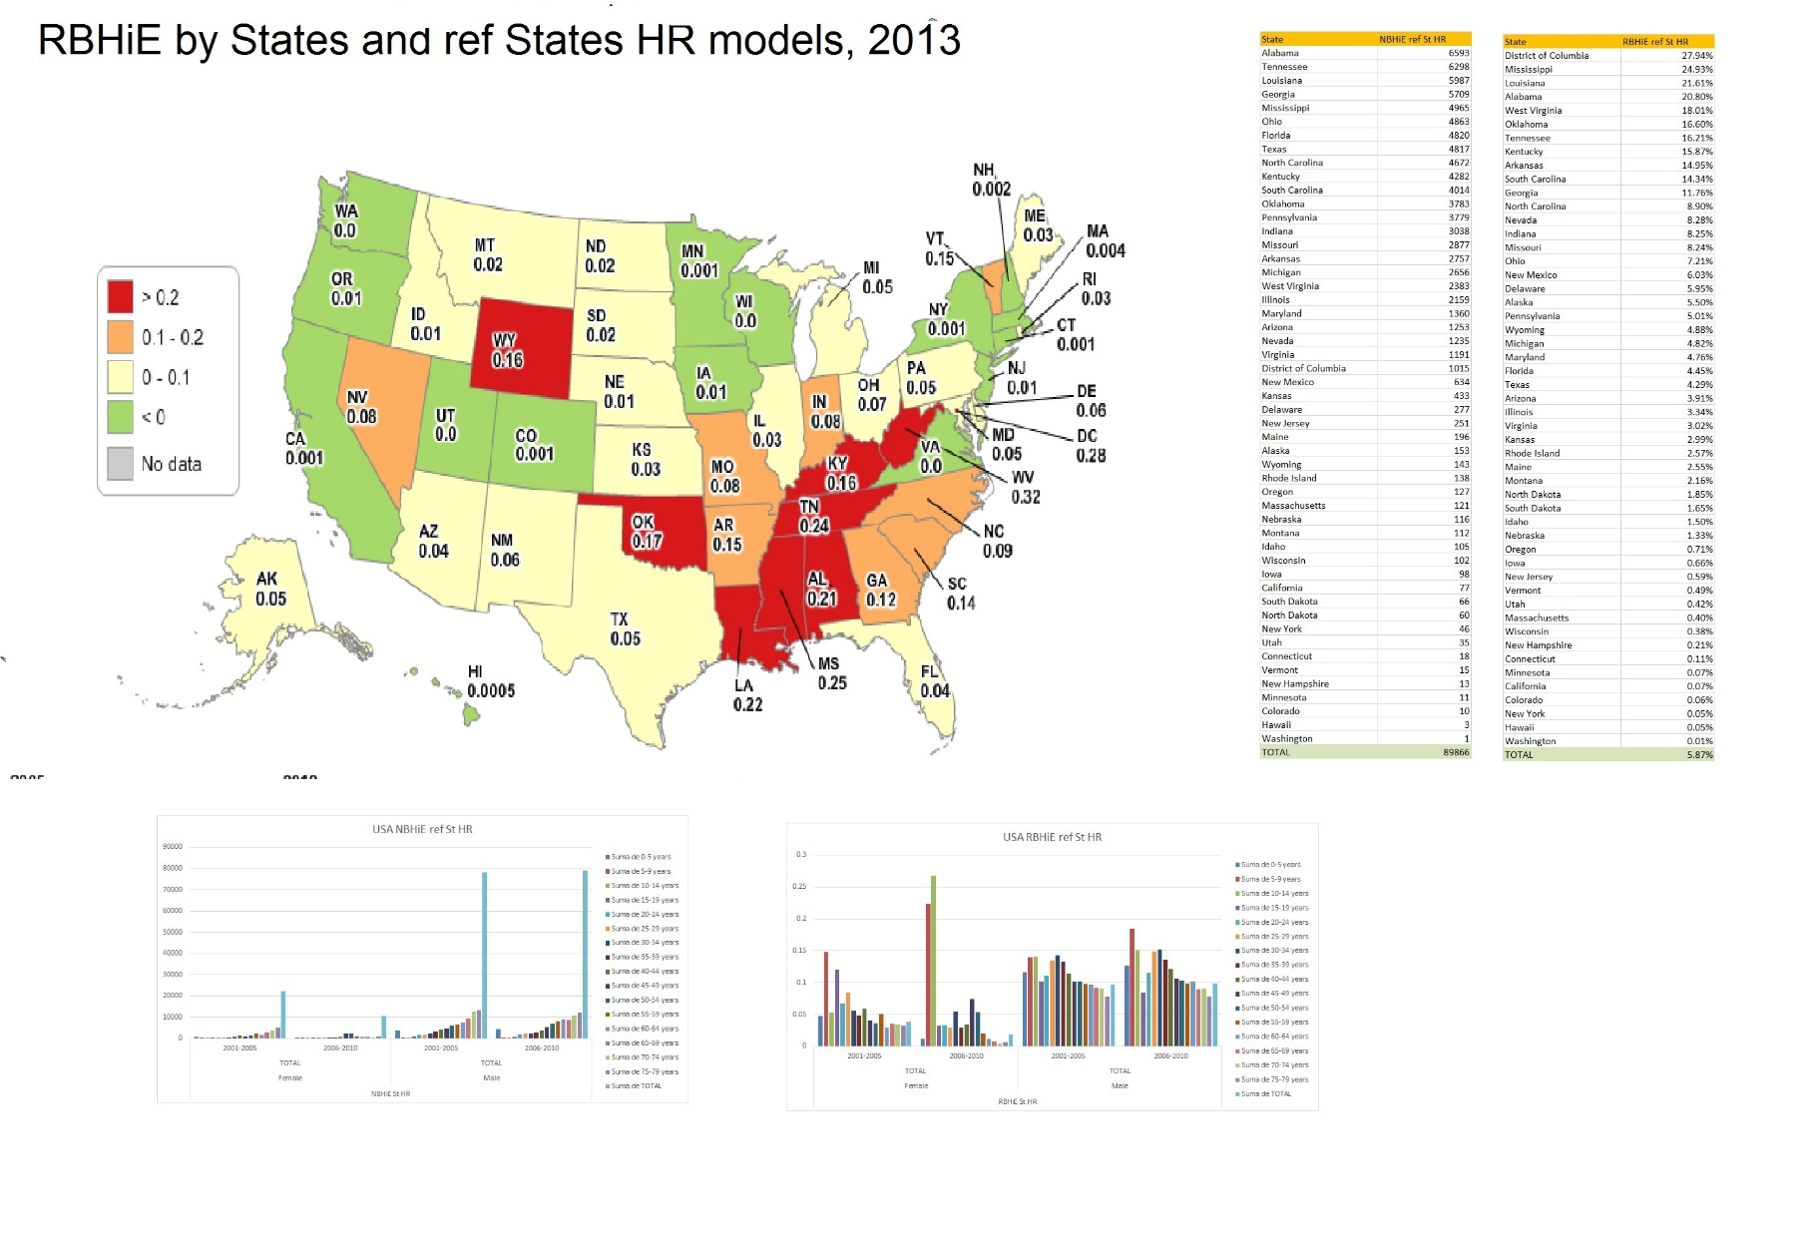

Figure 24 : USA states’ RBHiE REF States’ HR standards 2005-2010

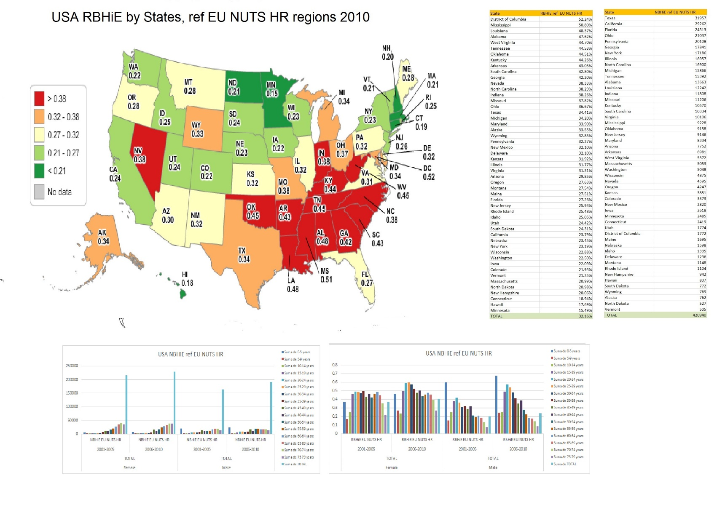

Figure 257 : USA states’ RBHiE REF EU NUTS2 HR standards 2005-2010

### USA health equity analysis at subnational County level

In an attempt to further disaggregate and better detect the level, distribution and trend of the burden of health inequity, we looked into disaggregated data of 2,679 counties[9] of the 3,144 total number of counties, where we could access data of population and deaths by sex and age group. This represents 60% of the USA, with a heterogeneous representation among States (as low as 13% in Wyoming and as high as 93% in Nevada), and among age groups (lowest but growing from 5 to 45 years old, rest around 80%), as the following graph shows.

#### Identification of HR Counties in the USA

We could get Life Expectancy, GDP pc and carbon emissions (State average) from countries representing 92% of the USA population.

In 2010, the weighted average of USA Counties’ Life Expectancy was 77.33 (compared to 79.89 for States) and the GDP pc weighted average was $ 17,842 pc (compared to $41,990 by States’ data). This significant differences are related to the data collected in the household income survey, which exclude corporate profits and capital gains, a growing share of the global economy,particulalry in the USA. There was a 0.33 correlation coeficient of algorithmic correlation between counties’ average GDP pc and their LE. Some examples of outliers are signaled in the graph.Interestingly, around the HR counties’ weighted average GDP pc, the correlation starts to flatten.

The carbon emissions were in all 3,144 recorded cases (in many the reported emissions were those of the States’ average) higher than the planetary boundary, with the lowest being Martin county , in Florida, with some 5 mT pc , twice the planetary boundary and the highest over 120 mT in Albany County, Wyoming.

A total of 749 counties met the USA counties’ HR criteria, signaled in the scater chart in the following graph in the upper left box. Their weighted average LE was 78,.50 years, 1.2 years above the estimated total of counties’ weighted average LE above mentioned. The HR counties’ weighted average GDP pc was $15,802, 11% lower ($ 2000) than the counties’ weighted average.

The following graph’s upper map represents the USA States according to the % of population living in HR counties which met the above mentioned HR criteria. As it illustrates, the north (with the exception of Maine State) is far more “HR-friendly” than the South and both Coasts, either due to poor health (more so in the Center and South East) or tohigher non-replicable income (more so in both southern coasts).

##### USA counties’ burden of health inequity by counties’ HR standards.

The USA counties’ burden of health inequity by the counties’ themselves weighted average HR standards (sex and age specific mortality rates) reveals as follows :

The total number of avoidable deaths in USA counties, by counties’ HR standards is of 134,804, ,some 50% higher than the NBHiE estimatesby States’ –NBHiE by States HR standards: 89,866; proving again the magnifying equity lense of disaggeragting both the standard geographical references and the units of analysis.

In terms of sex distribution, the USA counties’ NBHiE-counties HR is slightly higher for men than for women, and the RBHiE is lighly higher for women.

As regards the age distribution, women, like in the States’ analysis, have a very abrupt peak at a young age reaching average 20% of RBHiE in 5-10 years old, while men have higher RBHiE in the <5s (reaching also 20%) and in the 20-25 year old group.

The RBHiE by this method stands at 10.68%, twice the 5.87% estimated by the States’ analysis, but reaches 20% in the age groups mentioned above and 30% in Mississipi.

As above, the geographic distribution affcets mainly the South East with RBHiE >20-25% and also extending to West Virginia.

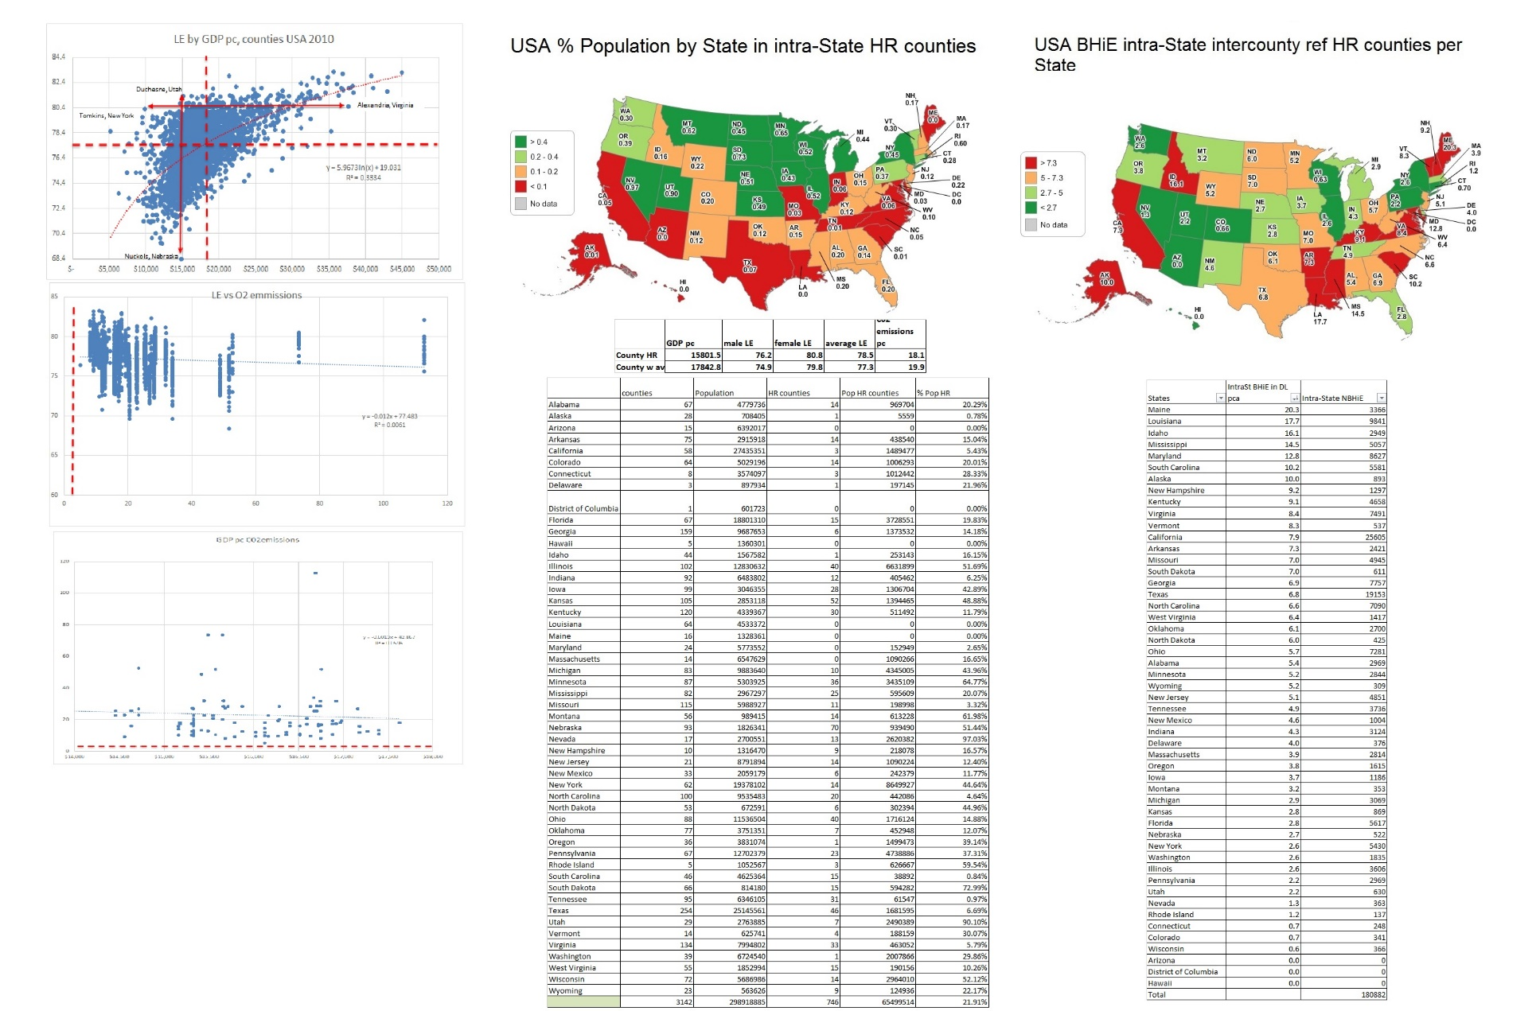

Figure 26: USA identification of HR counties and intra-State burden of health inequity, 2010.

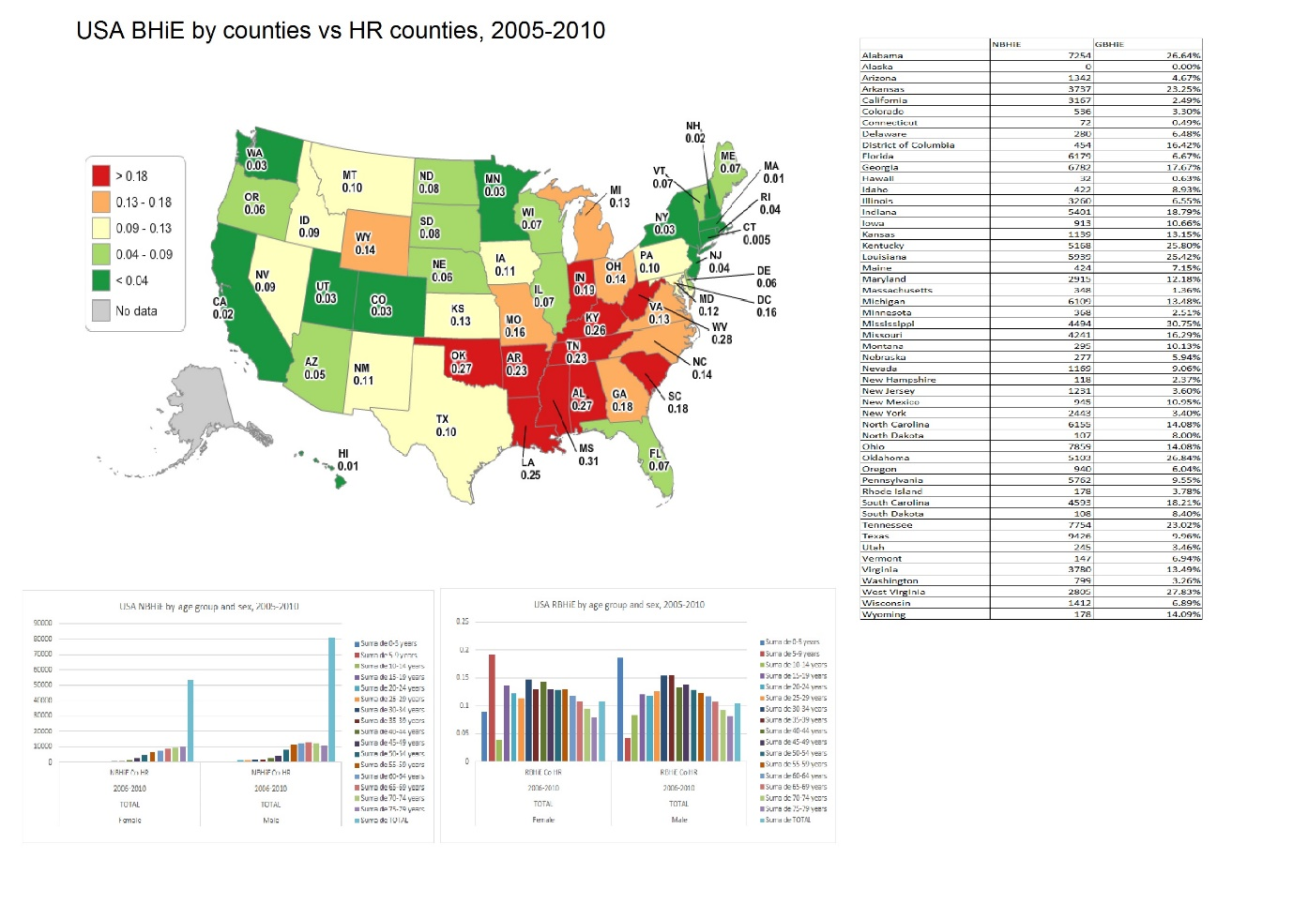

Figure 260 : USA Counties’’ RBHIE REF counties’ HR standards2005-2010

### USA counties’ burden of health inequity by EU NUTS HR standards.

The USA counties’ burden of health inequity by the EU NUTS 2 HR weighted average sex and age specific mortality rates (healthiest subregional references so far) reveals as follows :

The total number of avoidable deaths in USA counties, by EU NUTS2’ HR standards results in 234,567 , lower than the one estimated through States’ HR applied to average States population groups. This may be related to the fact that counties’ available records only cover 60% of the USA population so the figures hereby reported are most likely under-estimates. The fact that the RBHiE -32.16%, is higher than the estimated with the EU NUTS analysis -28.45%-,seems topiunt in that direction.

As regards sex distribution, the USA counties’ NBHiE-EU NUTS 2 HR analysis renders a 50% higher NBHiE for women and almost twice higher RBHiE , very similar to what we found through States’ analysis.

As regards the age distribution, women have, as in the States’ analysis, a quite even distribution in <5s and then from 15-70 years old , while men have a higher RBHiE in <5s and a pyramid-shape distribution peaking at 20-24year olds.

The geographic distribution is similar to that found in the previous analysis, worse in the South East, best in the North-East, Central north and West coast.

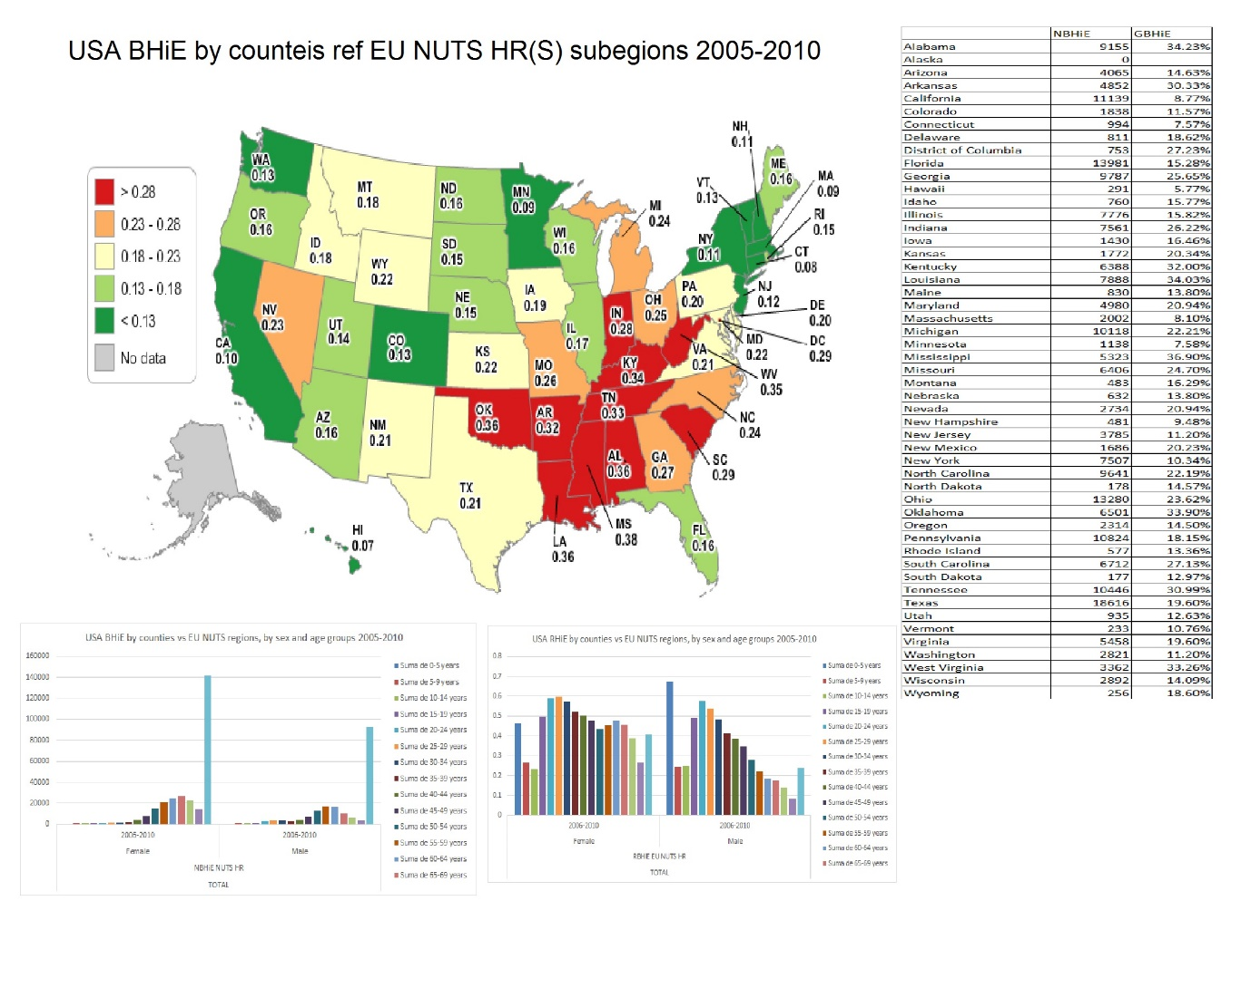

Figure 261 : USA Counties’’ RBHIE REF EU NUTS2 HR standards 2005-2010

Table 4 : comparative analysis of USA counties' burden of health inequity by referece models, 2005-2010

|  |  |  |  |  |  |
| --- | --- | --- | --- | --- | --- |
| Features | global HRS | Best SEW | States’ HR | Counties’ HR | EU NUTS2 HR |
| (GDP pc or reference as % of national average) | 6.5% | 18% | 73% | 63% | 29.5% |
| NBHiE(under-estimate) | **39,108** | **281,575** | **89,866** | **188,882** | **420,940** |
| RBHiE | 3.42% | 9.81% | 5.87% | 10.68% | 28.45% |
| Sex distribution | | | | | |
| NBHiE F:M | 2:1 | 1:1 | 0.6:1 | 1:1 | 1.5:1 |
| RBHiE F:M | 3:1 | 1:1 | 1.02:1 | 1:1 | 1.9:1 |
| Age distribution | | | | | |
| Women | Peak at 45-60 | Peak at 50-65 and >85 | <10s and even 15-70 | 5-10 years old and 30-40y | <5s and even 15-70 |
| Men | Peak at 30-40 | Peak at 50-65 and >85 | <5 and peak 20-24 | <5 and 30-50 years old | <5 and peak at 20-24 |
| Geographic distribution | | | | | |
| Worst affected | South East except Florida, up to Indiana | South East except Florida, up to Indiana | South East up to West Virginia | South East and extending to West Virginia. | South East up to West Virginia |
| Least affected | North East small States  West Coast, Hawaii  Central North, Alaska | North East small States  West Coast, Hawaii  Central North, Alaska | North East small States  West coast, Hawaii  Central North | North East small States  West Coast, Hawaii, Minnesota, Wyoming, Colorado | North East small States  West Coast, Hawaii, Minnesota, Wyoming, Colorado |

The table above shows that the comparative analysis of the USA States’ demographic data with international HRS, best SEW and EU NUTS (best subnational SEW) references, renders some 40,000, 280,000 and 420,000 excess deaths annually, while their GDP pc CV are 6,18 and 29% of the USA national average GDP pc. It is a clear example of how production, consumption and accumulation above the excess threshold does not improve wellbeing (proxy life expectancy) but even undermines it and (as the SEW index shows) that of others. The USA subnational analysis identifies some 90,000 excess deaths when compared with HR States (73% of national GDP pc) and 189,000 when done against HR counties (63% of national GDP pc), all of them far from ecologically sustainable and globally economically replicable.

In summary, inspired by HR counties, the USA could reduce some 40% of its unnecessary excess production and consumption GDP while saving over 188,000 deaths, more than 500 every day. It could even reduce it a further 30% if inspired in NUTS HR models, saving 420,000 deaths and even further 10% (total reduction of over 80%) if followed the best SEW index and fall within the equity curve. That would free some 15.8 Tn and double the need to fill in the GDP pc deficit of half the world’s population, and allow large investments in truly global public goods for the advance of humanity.

1. https://www.sciencedirect.com/science/article/pii/S0033350617301610
2. https://oxfordre.com/publichealth/view/10.1093/acrefore/9780190632366.001.0001/acrefore-9780190632366-e-62?rskey=fNaAhA&result=2
3. http://www.peah.it/2021/04/9658/
4. From 1960-2010 the countries which met all criteria constantly were Albania, Armenia, Belize, Colombia, Costa Rica, Cuba, Grenada, Saint Lucia, Saint Vincent, Georgia, Paraguay, Sri Lanka, Tonga and Vietnam, from 1960-2015 they were reduced to Armenia, Colombia, Costa Rica, Paraguay, Sri- Lanka and Tonga and from 1960-2020 only Sri Lanka remains.
5. The country with best SEW index, within the equity curve is Costa Rica.
6. <http://www.peah.it/2021/04/9658/>
7. <http://www.peah.it/2018/07/5498/>
8. https://www.usa.gov/statistics
9. https://www.usa.gov/statistics