Towards national and global public health models based on the ethics of equity: seven steps for a transformational change

Juan Garay

Summary:

Global health is framed in old concepts (Hippocratic oath 2500 years old), definitions (WHO health definition 60 years old) and objectives (WHO constitution 68 years old).

Even those old frameworks are not respected : The present landscape of global health lacks democratic governance (by all), accountability to its (untargeted and unmeasured) common objective (best possible health for all) and strategies at national and global levels which influence significantly root causes of ill health (in all policies).

In most cases, health policies are at best of a mitigating nature of health inequities and they often remain fragmented in terms of access and use of quality health services.

A methodology hereby proposed estimates that **global health inequity translates in some 20 million deaths every year, one in three deaths (unfair and avoidable),** a figure and proportion which have remained stagnant in the last 20 years.

The present document reviews and makes a **seven-step proposal** which includes the review of (1) the international definition of health leading to new ways of measuring health, (2) the operationalization of the universal right to health including responsibilities of all actors and revisiting the health professional code, (3) the respect of principles of health policies and initiatives, (4) the identification of root causes of social and ecological factors influencing health, (5) the review of the common global health objective and the need to monitor national and global burden of health inequity, (6) the national and international fair socio-economic conditions that enable the right to health and (7) an approach on global and national health policies based on the ethics of equity.

1. *Updating the World Health Organization definition of health : introducing a collective dimension of equity and sustainability, and exploring wider health indicators.*

At the time of the foundation of the World Health Organization, health was defined as “a state of complete physical, social and mental well-being, and not merely the absence of disease or infirmity”[1]. Such definition has been widely accepted and repeatedly quoted in the last 60 years, but paradoxically the psychological and social wellbeing dimensions have not been defined and no indicators have been agreed upon These dimensions are not captured in the world health statistics nor in any of the targets agreed in the thousands of world health resolutions or international agreements. Despite the global neglect this definition has been subject to, it also requires, in our opinion, some update or review: Firstly, the “complete” well-being may seldom be felt by most people, and rather we all *adjust to some acute or chronic health challenges and handicaps* so as to enjoy life personally and in our relation with society and nature. For instance, wearing glasses does not mean a limitation to our well-being. Secondly, our wellbeing should not be –by accumulating limited resources- at the expense of others’ health-, or based on the destruction of nature –at the expense of the health of next generations-. Individual health should therefore be qualified by its equity (linking it to the WHO constitutional objective, later discussed in step 4) and sustainability (adjusting this definition, and WHO’s objective, to the challenge of our times in back tracking the destruction of the nature and atmosphere we live in). We would hence propose an update in the definition of health linked with the global health objective which would read:

“*A state of well-being through the* ***adjustment*** *to physical, social and mental*

*challenges in an* ***equitable and sustainable*** *way which enables*

*the attainment of best feasible standards of health by all peoples*”.

According to this health definition proposed , individual health should also relate to the responsibility of the health of others (in our generation and those to come). This concept calls for new ways of acting on and measuring health beyond the its individual enjoyment.

At an individual level, we could measure our health not just in healthy life years, but also including the dimensions of social and mental wellbeing (as with the happiness index[2]). At a cololective level, we need to consider our effects on the health of others (staying below the maximum threshold of resources which prevents health equity) and of future generations (living below the maximum ethical limit of hectare use and carbon footprint to preserve nature for coming generations). Such consolidate health index would inform people and communities on the balance between their enjoyment of health and their effectcs on others.

1. *Recognition and operationalization of the right to health: State, international social and individual responsibilities.*

Health is a human right for some and a commodity or optional benefit for others. This is what differentiates the understanding of the roles of the state and civil society, the legal frameworks and the market regulations, and the national and global health policies and strategies.

The Charter of Human Rights, article 25[3], is clear on the right to health, and many of its determinants. Around the same time, the World Health Organization was founded with the objective, as mentioned in step 4, to achieve the best possible for all peoples. It took some 40 years to translate this into the International Covenant on Economic, Social and Cultural rights –hereafter ICESCRs-[4], which article 12 on the highest attainable standard of health, recognized in the State as the duty bearer of guaranteeing this right,. This Treaty has not been signed or ratified by 33 countries, including the United States[5]. It took another thirty years to gather just thirteen countries[6] to sign up its optional protocol and be subject to accountability mechanisms on economic, social and cultural rights.

But the recognition of the right to health remained a nice but non-binding declaration for most, and the majority of world’s citizens cannot report anywhere at national or international level, when their basic health needs or access to adequate health services are not met.

Interestingly, the global agreements or initiatives that targeted only some health problems or some populations, had more visibility and political and social attention. This was the case at the turn of the century for the health MDGs vs. the general comment on the Right to the Highest Attainable Standard of **Health** of the ICESCRs[7]. Probably the shorter term of results (yet partial and often short lived) of targeted initiatives provides the political credits during politician’s mandates and is more amenable to specific results and front-page news, than the longer term approach of establishing health right frameworks and universal and comprehensive health services which leave no people nor health conditions out.

*The first question in the international debates on health should therefore be, the recognition of the right to health in a binding and accountable way..*

There is a deep contradiction of some well-known countries in championing the cause of health at global level yet not recognizing the universal right to health at home. Before more and more declarations of commitment in improving the health of all, many of them repeated in cycles during the last 65 years, and expensive international conferences and grand declarations, all member states in the world should recognize the right to health and accept international means of reporting and verification..

Besides the State and International responsibilities as duty-bearers of guaranteeing the universal right to health, and according to the health definition proposed in chapter 1, the right to individual health should also relate to the responsibility of the health of others (in our generation and those to come) and the consolidate health index referred to in step 1 should assess and direct social and individual responsibilities towards the health of others in our and future generations.

This responsibility should also relate to the health professionals. Their shared code of ethics, the Hippocratic oath[8], 2500 years old, or various adaptations, in sworn by most medical students upon graduation[9]. It was adapted in 1948 by the World Medical Association as the [Declaration of Geneva](http://en.wikipedia.org/wiki/Declaration_of_Geneva) (Physician's Oath) and amended in 1968, 1983, 1994 with editorial revisions in 2005 and 2006. The text[10] still concentrates on the health professional´s duty for his or her individual patient. It has one sentence that related to equity[11] (how many doctors engaged in private practice- over half of the world´s health professionals- commit to their oath of "preventing social standing to intervene between their duty and their my patients"?) yet it does not relate to the right to health. The health professionals 'role in the universal right to health demands an additional sentence in the physicians 'oath when taking the responsibility of the health profession:

"In my personal and professional capacities,

I will preserve and promote the universal right to health"

1. *Setting principles for health strategies at local, national and global levels : From the philosophy of Primary Health Care to the principles of Global Health :*

In 1978 the International Conference of Alma-Ata[12] agreed on principles to advance on the health for all peoples, with an emphasis on the democratization of health through the recognition that health was to be achieved for all peoples and by all people. Some years after, the Ottawa charter[13] acknowledged that health was deeply related to all other policies, and it should be addressed in all policies.

From the nineties, the reference to the world’s shared health challenges was progressively referred as *Global Health,* gradually replacing the term of international health and recognizing the growing diversity of factors and actors influencing the health of all nations and peoples*.*

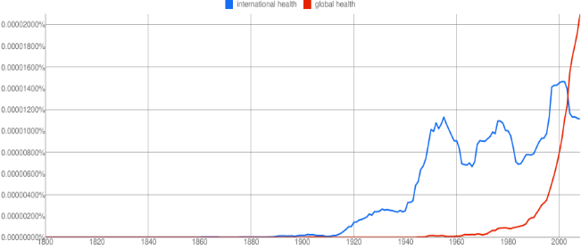

Figure 1 : Use of global health vs. international health in a sample of published books

The main principles of health agreed through the major international conferences in the last thirty years may be summarized as health for all peoples (WHO constitution – see step 4-), by all peoples (Alma Ata) and in all policies (Ottawa). These principles[14], however, are not reflected in many of the health initiatives claiming to be « global » while often restricted to some population groups or diseases –as even the health MDGs- (not for all), by some central decisions taken vertically far from the targeted communities, in capitals or even in Geneva or New York (not by all) or focused on medical interventions and detached from structural changes in socioeconomic policies (not in all policies). Many of these not-really « global » initiatives concentrate a large share of the international resources[15] for health and influence the international health agreements and commitments.

[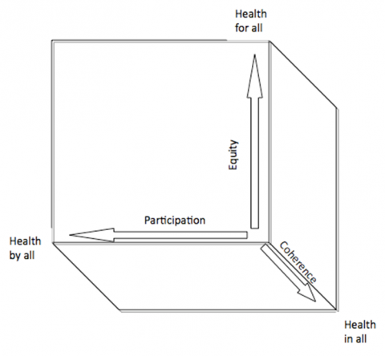](http://faceaface.revues.org/docannexe/image/745/img-6-small580.png)

Figure 2 : Principles and vectors of global health

The complexity of factors and actors influencing the world’s health, together with the biased interests for some issues or groups, often prioritized in arbitrary ways and influenced more by lobbies than by evidence, are also a reflection of a weak democratic governance of international health today. If we’d wish nothing less for the democratic governance of health than what we demand for a democratic government in all countries, we’d wish a democratic forum of health representatives (Ministers of health) which would gather in a parliament (World Health Assembly) and influence international decisions according to their population weight. At present, Nauru’s vote at the World Health Assembly counts as much as China’s, with over hundred thousand times population. Is that democratic? The resolutions proposed for this biased vote, are linked to targeted funding coming from those with greater financial capacity (hence influencing the international health agenda) or some private groups or foundations (one[16] being at present the largest founder of this meant-to-be international government of health). Imagine Coca-Cola contributing to a large share of your government’s budget and influencing laws, public investments and socioeconomic policies ?. What is most striking is that the funding to work on WHO governance reform comes from that major private donor[17]. A democratic WHO requires a budget through binding and regular contributions according to financial capacities (as in an equitable fiscal scheme).

*A truly democratic World Health Assembly should aim at commitments and resolutions into programmes aimed at health for all, by all and in all policies.*

1. *Identifying the root causes of health equity : Converging and structuring the health links to the social and environmental determinants*

WHO published a report[18] in 2004 of the weight of 24 health risks associated to mortality and morbidity. That report included risks related to childhood and maternal under nutrition, other nutrition-related risk factors and physical activity, addictive substances, sexual and reproductive health, environmental risks, occupational risks and others such as child sexual abuse or unsafe health-care injections. These factors included exposure to global dynamics (e.g. climate change), environmental (e.g. air pollution) or social (e.g. Child sexual abuse) hazards, unhealthy lifestyles (e.g. unsafe sex, physical inactivity or low fruit intake) or drugs (e.g. alcohol or tobacco), effects in blood markers (such as zinc, iron, vitamin A, cholesterol or glucose), clinical findings (as high blood pressure) or access to public health measures (such as contraceptives). Such mix of nature of the causes makes it difficult to assess the multivariate dynamics between them.

In 2009, the analysis of the Commission on Social Determinants for Health (CSDH) recommended –chapters 5-16 of the report[19]- actions in the areas of early child development, healthier and safer cities, quality housing, rural land tenure and rights; agricultural development, full and fair employment and decent work, universal comprehensive social protection, health-care services with the principle of universal coverage of quality services, progressive taxation, international finance for health equity, health and health equity impact assessments in national and international economic agreements , gender equity, fair representation in decision-making, supports to marginalized groups, in particular indigenous peoples and improvement of civil registration for births and deaths. Such long list of areas of action related to health and health equity lacks an analysis of their attributable risk to global or national health or health equity. Hence, the recommendations lack structural analysis and rationale in the selection of priority areas. For instance, progressive taxing and social spending through public financing is an structural condition for health, education and social protection services and should not be in the same lists of actions, but in a structured approach. On the other side some policy areas not as explicit in the recommendations such as secondary school drop-outs, people with disabilities, children rights, regulations on the production and marketing of unhealthy foods or the abuse of virtual media undermining physical and psycho-social activity, just to name a few.

Leter in 2013 the study of Global Burden of Disease of 2010 was published, and was based on a larger list of risk factors (67) influencing health which is also selected without a sufficiently described priority analysis and lacking a hierarchical structure of causes[20]. It again mixes the different hierarchies of cases from the 2004 report, it includes many new environmental and occupational chemical risks, and unhealthy dietary behaviors (though surprising advocating for cow’s milk), and surprisingly excludes others such as unsafe sex, claimed in 2004 to be the second attributable risk of ill health globally. In line with the influence of economic rather than democratic dynamics guiding the analysis, decisions and policies and actions of WHO, these reports have been led by the Institute of Health metrics and Evaluation, owned by the biggest WHO donor earlier mentioned.

In an attempt to structure the root causes of ill health and health inequities, we have used the logic of the Maslow pyramid to structure health needs, and grouped the root causes influencing those needs:

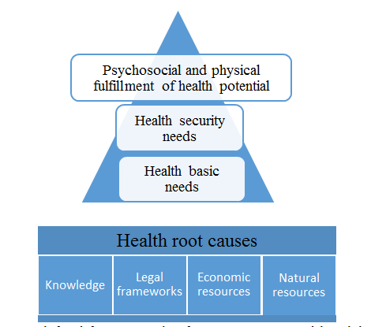

Figure 3 : Simplified framework of root causes and health needs

This framework may serve as a way to rationalize the somehow chaotic (if not biased) selection and categorization of causes influencing health, from the root causes to the satisfaction of health basic needs (water, nutrition ), security needs (from physical, chemical, biological or radio-magnetic –yet absent in the analysis- hazards) and the conditions to maximize our health potential in physical –including sexual- and psycho-social potentials (not as yet considered in any world health report and critical to mental health).

Root causes of how societies and persons are able to enjoy their health potential have to do with four main areas: legal and regulatory frameworks which ensure equal rights in relation to the needs mentioned above, an sustainable way of life which preserves the ecological environment for future generations , a balanced flow of information, knowledge and participation in society, and an equitable distribution of economic resources (including access to goods and services).

*The root causes of health are based on Equal rights, Sustainable relation with nature, balanced knowledge and participation and equitable distribution of resources.*

1. *Revisiting the global health objective and measuring global and national health equity :from ratios to targets, thresholds and health inequity burden as barometer of social cohesion.*

There is no common agreement at global level on the right to health (as many countries have not ratified the related international agreements) and there are many definitions , concepts and approaches to "global health"[21]. The only common framework for all UN member states is the constitution of the World Health Organization. Article 1 of the constitution of the WHO states that its objective would be “the attainment by all peoples of the highest standard of health”[22]. In relation to the proposed definitions of health in step 1, the challenges of rights and responsibilities for health stated in sept 2, the principles of health policies and actions referred to in step 3 and the main root causes of health in step 4, a revised artcle 68 years later would read :

*The international shared objective of global health is “the attainment by all peoples ,* ***within and between generations****,of the highest standard of health”*

Interestingly, there are an average of over thirty resolutions at the World Health Assembly and a dozen of international high level health conferences every year, over 150 global health initiatives[23], thousands of health indicators comparing health information within and between countries, an annual world health statistics report[24] with several hundred of indicators for each country and recently the global burden of disease analysis which allows a public online consultations of some six million national health data[25]. They all measure health situations, trends, services, financing, risks and even complex assessments of burden of ill health. For any alien –often asking the wisest questions- to health policies, this would be the first question:

“*Why did no one measure the progress of the founding article*

*of the World Health Organization*?”

The Commission on Social Determinants for health -CSDH- report calls on national governments to establish a national health equity surveillance system, with routine collection of data on social determinants of health and health inequity, and on WHO to steward the creation of a global health equity surveillance system as part of a wider global governance structure. Such call was reflected in the resolution of the World Health Assembly in 2009 on "Reducing health inequities through action on the social determinants of health"[26]. It calls on the international community "to consider health equity in working towards achievement of the core global development goals and to develop indicators to monitor progress… " and to member States "to develop, make use of, and, if necessary, improve health information systems and research capacity in order to monitor and measure the health of national populations, with disaggregated data such as age, gender, ethnicity, race, caste, occupation, education, income and employment where national law and context permit so that health inequities can be detected and the impact of policies on health equity measured".

So far the WHO equity monitor[27] has gathered disaggregated data of some reproductive and child health prevention and care services and health outcomes (fertility, child malnutrition, obesity and under five mortality) and ratios across three variables influencing health distribution : place of residence (urban or rural), education level of the mother (none, primary or secondary) and income quintiles (first, second, third, fourth and fifth quintile), and a fourth, sex, when assessing children indicators.

On average, data are reported from some 60 countries (less than a third of all), all of them low and middle income countries, and most of the data are from demographic health surveys which date back five years or more.

This response, already five years after the CSDH report, is very limited, in the proportion of countries reporting (less than a third of all countries and none of the high income countries reported to WHO on health equity[28]), in the population sub-groups targeted (under-fives and pregnant women, less than a third of the population in those countries), the health indicators assessed ( access to some services (vaccinations and save deliveries) and under five mortality) and in the disaggregation by variables (mother’s education level, income quintiles and rural/urban). On the other side, the analysis only measures ratios or comparisons, and cannot estimate the burden of health inequity.

*Estimating the burden of health inequity requires two steps: defining or at least estimating the “highest attainable standard of health”*

*and measuring how it reaches (or fails to do so) all peoples.*

In order to estimate the burden of health inequity we need to first agree on its definition. Equity is not equality. A state of inequity is a situation with unfair levels of inequality (inequalities being a constant feature of the distribution of variables in nature).. Hence, health equity is the fair distribution of health inequalities.Whitehead (1992)[29]added to the unfair dimension, the feature of **“**avoidable”, interestingly reflecting the WHO’s constitutional objective of best “feasible” levels of health for all.

But which are the fair levels of inequalities? Inequalities are a mathematic feature measured, in a large enough sample where variables tend to have a “normal” distribution, by the standard deviation (average differences with the mean value) and the dispersion index (the relation of the standard deviation, to the mean). Some development indexes are based on statistical measures: for instance, the Human Poverty Index for OECD countries[30] includes a so-called “dimension of social exclusion” as the proportion of people with income below the “poverty line”, defined –arbitrarily- as 50% of the median (less affected than the mean by extreme values) adjusted household disposable income. But what is a fair distribution in health? Which standard deviation is acceptable? And which should be the minimum threshold? The statistical approach can only be chosen by convention and, besides, would not be correlated to the underlying causes of health inequalities. Moreover, the inequality of health indicators may be due to genetic or epidemiological conditions unamenable to change. Setting best standards on a pure statistical basis (such as 50% of the median life expectancy, as done in the OECD poverty index) would possibly not be achievable for all. Identifying fair limits of inequality through the distribution of the most influencing variable (amenable to change) of health distribution, adds an ethical component essential to the concept of equity. In 2006 Paula Braveman proposed a definition of health inequity in this sense: “Systematic health differences between socially advantaged and disadvantaged groups”[31]. If we combine the features of Whitehead and Braveman’s definitions, we would point at a threshold of health equity based on social differences which are unfair and avoidable.

So, the first challenge is to define the most influential variable conditioning health differences. If we assess –with national average values- the correlation of health indicators with the variables measuring each of the root causes proposed in step 4, we would observe the following relations[32]:

The UN democracy index includes a number of features related to freedom and participation rights and the governance role of the state in promoting and respecting its citizen’s rights. The correlation between national indexes and life expectancy national means is quite high (r2=0,50, p<0,01) yet if we would use a weighted averages according to population sizes, it would be lower given the discrepancy values of China and India (better health of the former, with lower democracy index).

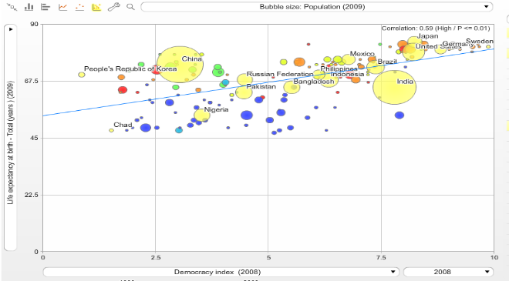

Figure 4 : Correlation between democracy index and life expectancy

Regarding the root cause of knowledge (and we would need to correlate it with factors previously included in the democracy index, such as –knowledge based- social –not just political- participation), there is an even higher correlation between the average number of years of education (from primary to university) and the average life expectancy (0,81, p<0,01). However, the sample is limited as so is the information available from many countries, and, on the other side, recent evidence as the PISA studies, tells us that the quality of education is more important than the quantity and we should take the latter with caution.

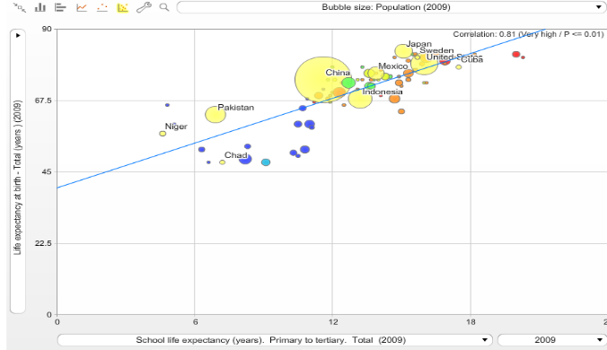

Figure 5 : Correlation between years of education and life expectancy

The ecological environment is truly an essential condition for a healthy life. However, there is a profound contradiction in this correlation: those countries – and populations within countries- enjoying best health indicators, are often also those depleting natural resources (in hectare use per capita) and polluting the atmosphere (in CO2 emissions) at a higher rate. It is therefore a complex variable which requires global responsibility and we will not include it in this analysis aimed at identifying the most influential variable on the distribution of health.

The root cause of equitable distribution of resources is closely correlated to the distribution of health. When correlating national averages of per capita GDP[33] with life expectancy, we find a strong logarithmic correlation (known as the Preston curve) which would explain some 70% of those differences. In large enough samples we may likely also find that through multivariate analysis this correlation does not only remain but is strengthened by the influence of income in the access to education and the exercise of rights. This correlation is slightly lower for healthy life expectancy and for under-five mortality, especially in girls, as the table below shows.



Figure 6 : Correlation between GDP per capita and life expectancy



Figure 7 : Correlation between GDP per capita and main health indicators

What is most interesting of this correlation is that above some 12000 GDP pc, there is no correlation, that is, higher level of resources does not translate in higher levels of life expectancy[34].

So, the main variable influencing the distribution of health across countries is income, measured in GDP per capita. If we go back to the definition of the right to health, it should be universal regardless of social condition. The mean value of life expectancy of the countries –and populations in countries- enjoying the higher income levels, should be hence considered as the level of life expectancy desired for all (regardless their social conditions). For practical purpose, and also with the statistical rationale of a large enough sample to allow unavoidable differences –geographic, genetic, others-, the upper income quintile in countries and the high income countries in the world, could be taken as the reference populations enjoying the best conditions (income) and the best life expectancies, desirable for all.

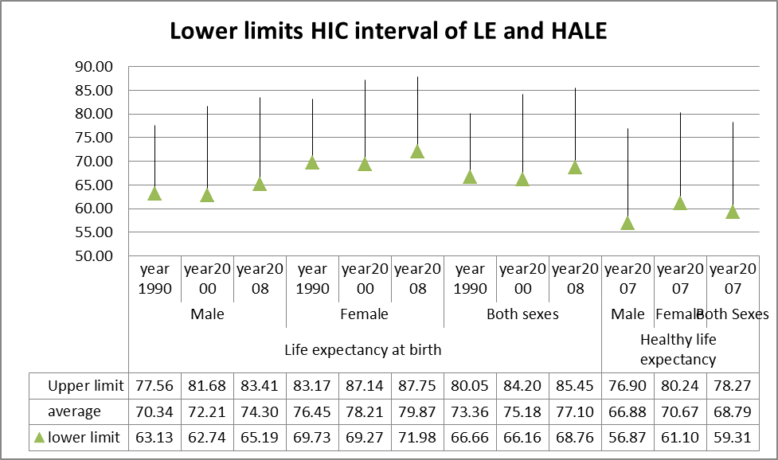

Figure 8 : Confidence intervals of health indicators in high income countries

But are these differences in life expectancy related to higher income conditions, avoidable? The average income levels in the high income countries is of over 20,000 GDP pc, having doubled in the last 20 years. Clearly, these income levels and trend are not replicable for the whole of the world’s population as there would not be enough resources for all. In fact, their levels of consumption are already undermining the health of future generations. On the other side, none of the high income countries in the world and during the last 20 years, has had ecological rates in terms of hectare use per capita or carbon emissions, replicable at global level to allow the recyclable capacity of the planet. Hence, high income countries are not replicable nor sustainable development models. However, there are a number of countries, some with even below 50% of the world’s median GDP, which are based on ecologically sustainable economies and enjoy as well health indicators within the confidence interval (p<0,05) of high income countries[35]. These models prove right the third feature for health equity thresholds: that the income differences are avoidable in a world with a fair degree of inequality and yet preserving resources for future generations (inter-generational equity).

Once we agree that the mean health indicators of high income countries are the health standards desirable and feasible globally (WHO’s original objective “best health for all”), we can estimate the health inequity burden: the difference between the present health situation and the desired/feasible one. The graph below shows that, according to the world health statistics, life expectancy has increased in a parallel way across all income regions, yet maintaining the inequalities. The lag time of the lower income countries in enjoying –through collevctive but unequal pace of progress- better health, translates –as the analysis hereforth will show- in million of deaths. Are these inequalities fair? Are these deaths avoidable?



Figure 9 : Trend of life expectancy across low, middle and high income countries 1990-2000 and 2010.

Any information on the progress or failure on the objective of health equity at country or global levels, needs to be accessible and easy to interpret by statisticians, health professionals, policy makers, politicians and civil society alike. In contrast with complex statistical dispersion measures (such as GINI and others), the concept of avoidable deaths is easy to understand by most people. Over 90% of the premature deaths before the lower limit of the confidence interval of life expectancy of high income countries (68,7 years) take place during the first five years of life (under five mortality) and from 15 to 60 years of age (adult mortality) and there are international data of both. When we compare, adjusting for demographic data (adjusted mortality rates), the present and desired under-five and adult mortalities, we estimate the excess mortality due to global health inequity: the Global Inequity Death Toll (GIDT)[36].

We can then apply – with data from the world health statistics annual reports- the desired high income adult and under five mortality rates to the under-five and adult populations of the other-than high income countries, and compare that figure with the present levels of under-five and adult deaths in low and middle income countries.

The following graphs show those figures and proportions, by age group and income groups[37].

*The estimates of excess mortality due to global inequity is close to 20 million deaths per year. This represents over one third of all deaths and the numbers and proportions have remained stagnant over the last two decades.*

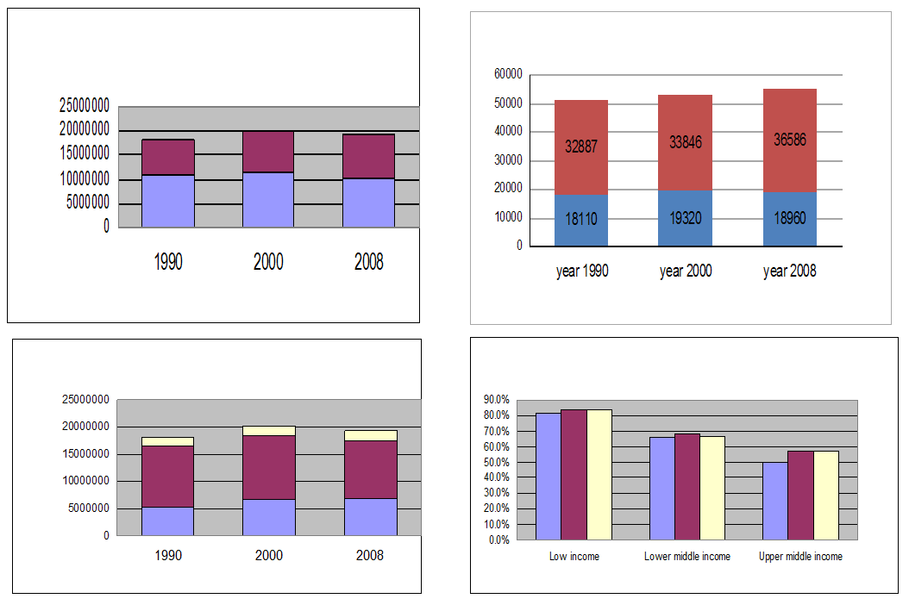

Figure 10 : Global health inequity death toll (GIDT) based on World health Statistics data 1990-2010 by : Top right :age groups (<5s and adult), Lower right : income groups of countries, Top left :Proportion of all deaths and Lower left : proportion of all deaths

When the data of the GBD 2010 were made public, with estimates of national average mortality rates since 1970 by five year age groups, we replicated the foirmer analysis of GIDT,, this time with a much finer age adjustment of mortality rates by 190 countries, during 40 years and across 16 age groups each country and year. The results are very similar to the more gross estimates based on under-five and adult mortality rates alone form the World Health Statistics, and confirm the hypothesis of a very high and stagnant level of health inequity[38]:

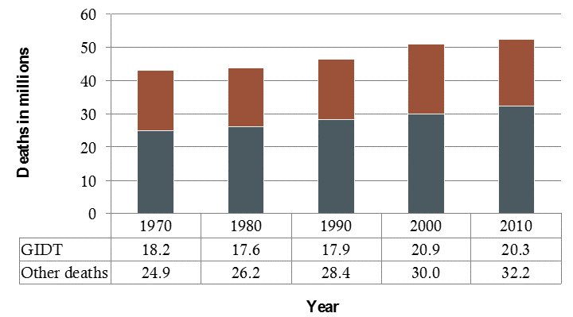

Figure 11 : GIDT net and proportion values based on GBD data analysis 1970-2010.

The share of GIDT by iincome country groups shows that while the low income countries have a greater share of GIDT of their overall deaths (71%), middle income countries account (given their larger share of the world´s population) to over 75% of all avoidable deaths. This share may be even larger when data of burden of national health inequity become available, given thei high income inequity rates.

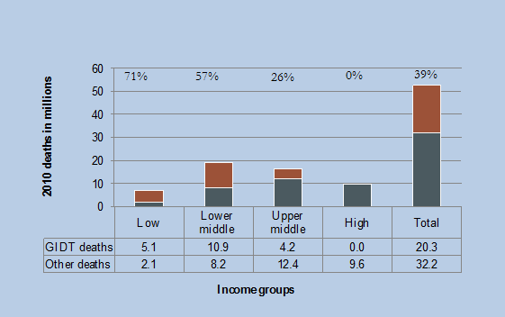

Figure 12 : GIDT as proportion of all deaths, by income country groups, 2010.

Through this fine age disaggregation, we could also estimate the share of GIDT by each age group and throughout the ten year intervals of the last 40 years[39]. As the graphs below show, the larger share of the GIDT is concentrated in the under-fives. However, such share has been reduced to less than half of the baseline level in 1970 (still the share of the GIDT from all deaths in under-fives has slightly increased) while older age groups are gradually traking a greatr share of equity-avoidable deaths.

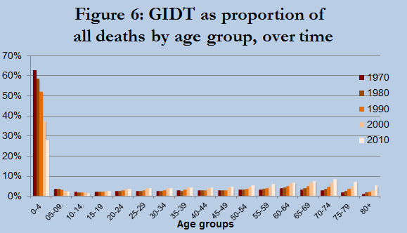

Figure 13 : GIDT as proportion of all deaths by age group, 1970-2010.

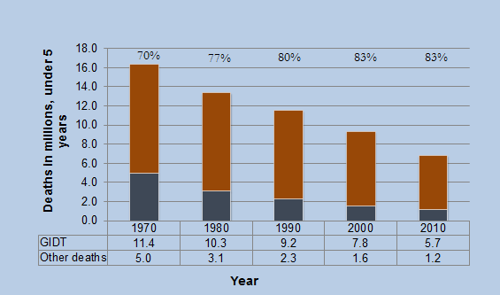

Figure 14 : GIDT as proportion of deaths in under-fives, 1970-2010

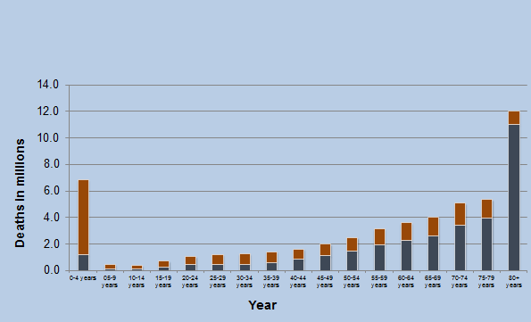

Figure 15 : GIDT as proportion of all deaths by 5 year-age groups, in 2010.

This method may be applied to estimate the levels of national health equity, if the adult and under-five, or even narrower age groups’ mortality rates are known disaggregated by income groups. At present, as mentioned above, WHO only reports health equity indicators from one in three countries, and only on under five mortality.

WHO should expand the health equity monitor approach to cover for all countries, all age groups, and aim, by setting best health targets, at measuring the burden of health equity, in excess mortality and burden of disease. Countries should set health equity surveillance systems, as the one being prepared in Uruguay[40], and assess the burden of health inequity due to global (if the average health indicators of high income countries are better than the country’s upper quintile’s) and national (comparing the present situation with that if the average health indicators would equal those of the upper income quintile).

*As the burden of health inequity is influenced by the root legal, knowledge and resource frameworks, and by every single sector policy, it reflects the best indicator of social cohesion.*

An international reference center with research, academic and support facilities on the methodology, analysis, design and implementation of health equity surveillance systems, and strategies to link evidence with transformational policies should be developed.

A more complex dimension of health inequity is the relation between our abuse of natural resources and the effect it may have in future generations deprived of one of the main root causes enabling the right to health: a sustainable natural environment. Some have referred to inter-generational health equity as the social and health differences (and mobility between them) among age groups sharing a period of time[41]. Here we refer to inter-generational health equity as the fair distribution between generations not sharing lifetime, following concepts and debates around inter-generational justice in the context of climate change concerns[42].

*What do we leave for coming generations regarding health conditions,*

*after we are gone?*

We may live equal legal frameworks, equitable economic systems and advanced knowledge and access to it, but we may be neutralizing and even offsetting those developments by the destruction of natural resources and biodiversity. The effects in health of climate change are many-fold[43] but lack estimates on the burden of disease it may be attributable to, and hence we are still far from a methodology that enables the estimation of the burden of inter-generational health inequity.

*Our carbon foot print beyond the ethical limits to preserve nature, is correlated with excess disease and avoidable deaths of future generations,*

1. *Agreeing on an international convention to ensure universal minimum threshold of human dignity which enables the universal right to health and health equity: towards a sufficient, equitable, aligned and binding framework based on national and global ethical responsibility*

Once the conditions exist for equal rights , including access to information and participation, intra-generational national and global health inequities are related to the unfair distribution of economic resources, while inter-generational ones are related to the unfair abuse of nature, reflected in individual, national and global rates of hectare use and carbon emissions.

At global level, the only mitigation to this unfair distribution causing such tragic annual death toll is the international cooperation. The level of cooperation was arbitrarily[44] targeted (yet not complied by most) at 0,7% over 40 years ago. Such target was never based, nor adjusted, on an analysis of redistribution needs.

The definition of best and feasible health standards for all, not only allows the monitoring of the burden of health inequity (the gap towards WHO´s constitutional objective) but also enables the analysis of the minimum level of economic resources to allow the opportunity to enjoy the right to health. Such level is defined as the threshold of economic resources (at global measured in GDP pc) below which no country in no time has reached the best and feasible health standards for all. Such threshold, based on analysis over the last 40 years, results in some 3000 GDP pc in PPP US $[45], and affects over 60 countries at present with a total population of 1200 million people.

*The threshold of minimum GDP per capita (proxy to household income per person) to enjoy the universal right to health is at 10 US $ /day, eight times higher than the World Bank threshold of extreme poverty of 1.25 US $/day).*

The overall GDP deficit of these countries is 2,2 trillion dollars annually, some 0,31% of the world´s GDP[46] (half the 0,7 target of OECD DAC countries). According to the world´s average of public revenues from GDPs, close to 20%, the gap of public resources in those countries to finance social services and regulate and invest in inclusive and sustainable economies, would be of 440 Bn US $, some four times the present levels of ODA yet only 0,006% of the world´s GDP, a tenth of the OECD DAC 0,7% target. The remaining 80% of the gap, should flow through economic investments, non-profit global citizen´s solidarity and subsidized public goods.

Based on this gap analysis, unlike the arbitrary 0,7% and other targets, there are two dilemmas to face :

**First**: In a world with one fifth of the population living in countries with insufficient resources to enable the right to health (undermining the very right to life), is the accumulation of resources by some countries and some groups within those countries ethical, with the objective of constant growth? Isn´t the extreme poverty mathematically related to the extreme abundance? In a normal distribution, if we want to limit the lower end (minimum threshold) to a minimum (say less than 1%, and ensure social protection mechanisms to detect and rescue that group), knowing the average (10,170 US $ at present), we may estimate the maximum threshold which should also be limited to < 1% and, as with the group under the minimum threshold, have fiscal mechanisms to detect, limit and redistribute ("rescue", although their perception would probably be different!) those excesses. With the above mentioned minimum threshold at 3000 US $ GDP PPP and present average of 10,170 US $, the maximum threshold would be at 17,000 GDP pc, close to the average of the top quintile GDP countries. The maximum equitable (ethical) ratio, therefore, between the lower income group and the higher income group, should be of seven. While the ratio between the top 20% of the world´s population by average country GDP (some 18,000 GDP pc) and the lowest 20% (some 3300 GDP pc) is around 7, it leaves a high proportion, most of the lower quintile, below the minimum threshold to enjoy the right to (best feasible for all) health and life. At present, the ratio between the highest (Quatar) and lowest (DRC) country GDP pc is at 220 times[47] and the ratio between the highest 1% (70 million) national average income GDP (60,000 GDP pc) and the lowest(450 GDP pc) is of 144 times.

*In a fair world, the difference between both 1% income extremes should be less than 7, and include mechanisms to bring those two groups to the fair limits of wealth distribution compatible with the universal right to health and life.*

The dilemma therefore is : in the context of 20 million deaths every year due to unfair distribution of resources, is it ethical for those (the top quintile) living with some seven times higher resources than needed to enjoy the right to health (and life!) to have no other socioeconomic model than constant growth?

Two other factors that reinforce this dilemma are the facts that no country above those levels of resources per capita has based its economy in eco-sustainable levels (measured by hectare use per capita and carbon emissions)[48] rendering therefore *inter-generational inequity (still void of methods or estimates to asses its potential burden)*, and, on the other side, and as indicated in the curve correlating resources with life expectancy, beyond those levels of resources health does not improve, and this also applies to most indicators of social wellbeing[49]. Hence, GDPs pc above 18,000 are to be questioned, and their growth obsession double questioned.

**Second**: How could the level of unmet minimum resources for the world´s lower income quintile be met by a global redistributive mechanism aimed at a minimum level of resources for dignity and the right to health and life? Based on the universal principle of human rights, we should want for all world´s citizens what we want for our fellow-countrymen. This is a challenge for development cooperation, based on old concepts (donor-recipient) and double standards (policy for "donors´s citizens" and other for "recipients´ citizens"). At country level, governments with a social model where the State aims at guaranteeing their citizens´ human rights (prior to the market and capital "rights") decide on economic regulations, fiscal redistributions and public social spending to prevent or limit the conditions of poverty of their citizens. Such mechanisms are binding (through taxes) and progressive in a way that (should) limit both ends: poverty and excess abundance. The European Union model has achieved the world´s highest levels of income equity and social rights, including intra-regional health equity[50]. This is based on the best levels of redistributive efficiency of fiscal systems and public transfers [51] (yet decreasing)[52]. Some 80% of those public revenues come from direct taxes to individual incomes and properties, and 20% from indirect taxes (lower redistributive effect given its horizontal nature) on consumption [53], with over 25% spending on social protection, health and education.

What is missing in present-days fiscal systems is a relation (which could be mathematically estimated) between the GINI index to ensure the fair distribution of resources enabling the right to health and life in each context, and the progressivity of taxes and between the carbon footprint and a policy on direct taxes to adjust production and consumption to eco-sustainable levels (and inter-generational inequity).

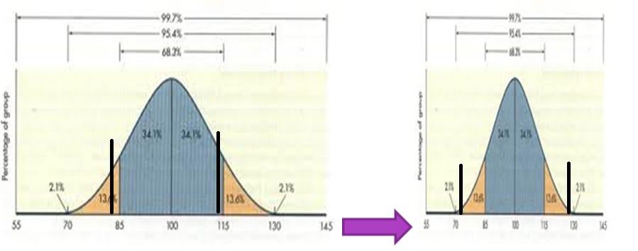

Figure 16 : Narrowing the health gaps between and within countries to fair levels of inequality (equity)

If we were to apply, in a universal ethical way, the best national social models enabling low levels on inequity, to the world´s required levels of international solidarity, the levels of contribution from countries above the minimum threshold, to a global solidarity fund for countries with resources below the minimum requirements for the right to health, would range, in a progressive mode, from 0.1% of the low-middle income countries to some 1.5% of the high income countries. Additional contribution mechanisms would tax international trade in a progressive way (by nature of goods and of trade partners). Such fair redistributive global scheme would also support progress on global public goods and continue enabling progress, yet in an equitable way (including the limitations of patent rights when they endanger the right to life) and preventing the tragic and silent global death inequity toll.

The same dilemmas of upper and lower thresholds, growth and fiscal and social spending systems should apply at national levels, to ensure national health equity and universal right to health and life.

1. *Public health strategy based on the ethics of equity: from mitigation to transformation.*

Both at global and at national levels, the evidence presented above demands a new public health strategy that truly includes the principles of health by all, for all and in all, in a transformational way.

At present, most health policies, strategies and services, focus on the provision of health services aimed at being universal and equitable. The objective of universal health coverage (UHC) being championed by WHO[54], the World Bank[55], the discussions towards post 2015 goals and strategies such as the GH2035 initiative[56], are complacent with national inequities in access ( allowing for fragmented systems and market asymmetries in insurance and provision, hence "universal health affiliation" rather than universal and equitable health coverage –UEHC ) and international double standards (see GH2035 goals for low and middle income countries while high income countries continue their priviledges in income and health conditions…)[57]. The equity in the access to and use of health services is most often missing or very weak given the predominant fragmentation of health services in their financing and or provision, according to the income and labor nature of the citizens. Only a dozen of systems worldwide have pooled health financing for and equal to all citizens, but they are gradually suffering as well the infiltration of private insurances and providers capturing a growing share of the middle class as health care costs of progressively unhealthy (and in a parallel way un-eco-sustainable) lifestyles and an high margins of the health care industry, continue to rise. After the Ottawa charter, it became clear that the best provision of health preventive and curative services would, at best, rescue some 30% of the health lost to other causes beyond the health sector.

Thereafter, the strategies of "health in all policies" have progressed in many countries through health impact assessment of sectors influencing health outcomes. However, the level in which health has influenced critical policies to health levels and its distribution has been, to be very diplomatic, limited, For instance, how health influences the most influencing variable in the access and satisfaction of health needs, protection and potential, that is, resources, through economic regulations and fiscal redistribution, has been very exceptional and limited. In general, the provision of health preventive and curative services, and the influence in some other policies often aimed at limiting their potential negative impact, has been of a mitigating nature, far from addressing and changing the "factory of inequality" underlying the dynamics of health inequity. As countries comply with their reporting on national health inequities, we may see which multi-sectorial health policies have a greater impact in reducing health inequities.

A new philosophy and strategy of public health based on the ethics of equity, will require some preconditions : to be based on legal frameworks that ensure equal rights for all (including the access to equal scope and quality of health preventive and care services), with address equity in all policies and which ensure participatory mechanisms so that all citizen have access to the information on the health distribution, its dynamics and the public policies and finance mechanisms to aim at greater equity, so that health is by all.

Once these preconditions are met, the best feasible state of health should be agreed upon, starting from some global minimum levels, as described in the previous sections.

Such target will allow the definition of the burden of health inequity through healthy live years lost and through excess (and avoidable) deaths (a more understandable notion for all). The burden of health inequity should be one of the key indicators in measuring the inclusiveness of a society and its socioeconomic policies and strategies. It is the best indicator of social cohesion as no other one incorporates the dynamics of virtually all social and ecological factors and policies.

The (unfair) distribution of the most influencing variables of root causes of ill health and unequitable distribution (mainly income, knowledge/education and geographic settings -which combines the ecological and social conditions-) may then be assessed by their contribution to the burden of inequity. What is most important, the threshold of these conditions under which the enjoyment of the right to health and its standards is not feasible, should be set.

A health policy based on the thics of equity should define minimum thresholds of the root causes influencing health and influence structural changes in policies ensuring the prevention of such conditions.

*Traditional health policies and services can only mitigate the root causes of health inequity. The strategy of public health based on the ethics of equity influences the root causes of social inequities.*

Equity should also be the guiding principle in all health information systems by disaggregating data by the root causes (income, education, location) and the fixed determinants (such as sex, age and ethnic origin). Disaggregated data collection and analysis of health related information (including lifestyles, risks, incidence of diseases and access, use and quality of preventive and health care services) will enable the equity focus in health services and all other policies.

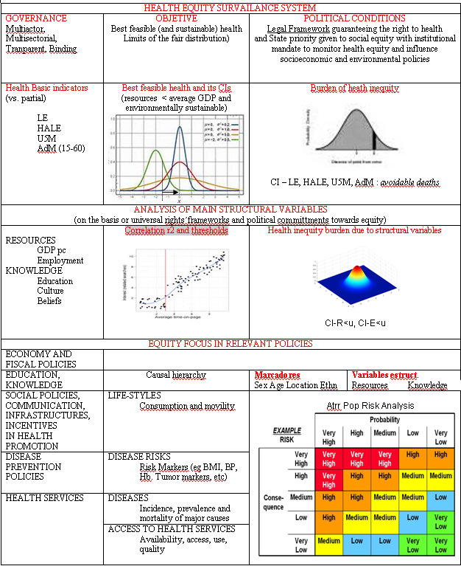

Figure 17 : Public health strategic framework based on the ethics of equity

1. http://www.who.int/about/definition/en/print.html
2. http://unsdsn.org/wp-content/uploads/2014/02/WorldHappinessReport2013_online.pdf
3. http://www.un.org/en/documents/udhr/index.shtml#a25
4. https://treaties.un.org
5. [Economic, Social and Cultural Rights: Questions and Answers"](http://www.amnestyusa.org/escr/files/escr_qa.pdf) (PDF). Amnesty International. p. 6. Retrieved 2 June 2008. : "The United States signed the Covenant in 1979 under the Carter administration but is not fully bound by it until it is ratified. For political reasons, the Carter administration did not push for the necessary review of the Covenant by the Senate, which must give its 'advice and consent' before the US can ratify a treaty. The Reagan and George H.W. Bush administrations took the view that economic, social, and cultural rights were not really rights but merely desirable social goals and therefore should not be the object of binding treaties. The Clinton Administration did not deny the nature of these rights but did not find it politically expedient to engage in a battle with Congress over the Covenant. The George W. Bush administration followed in line with the view of the previous Bush administration.The Obama Administration stated it does not seek action at this time on the Covenant".
6. Argentina, Bosnia, Ecuador, Salvador, Finlandia, Gabon, Mongolia, Montenegro, Portugal, Slovakia, Spain, Uruguay.
7. http://www.nesri.org/sites/default/files/Right_to_health_Comment_14.pdf
8. The Hippocratic oath: text, translation and interpretation by Ludwig Edelstein Page 56 [ISBN 978-0-8018-0184-6](http://en.wikipedia.org/wiki/Special:BookSources/9780801801846) (1943)
9. Sritharan, Kaji; Georgina Russell, Zoe Fritz, Davina Wong, Matthew Rollin, Jake Dunning, Bruce Wayne, Philip Morgan, Catherine Sheehan (December 2000). ["Medical oaths and declarations"](http://www.ncbi.nlm.nih.gov/pmc/articles/PMC1121898). *BMJ* **323** (7327): 1440–1. [doi](http://en.wikipedia.org/wiki/Digital_object_identifier" \o "Digital object identifier):[10.1136/bmj.323.7327.1440](http://dx.doi.org/10.1136%2Fbmj.323.7327.1440). [PMC](http://en.wikipedia.org/wiki/PubMed_Central" \o "PubMed Central) [1121898](http://www.ncbi.nlm.nih.gov/pmc/articles/PMC1121898). [PMID](http://en.wikipedia.org/wiki/PubMed_Identifier" \o "PubMed Identifier) [11751345](http://www.ncbi.nlm.nih.gov/pubmed/11751345).
10. http://www.wma.net/en/30publications/10policies/g1/
11. "I WILL NOT PERMIT considerations of age, disease or disability, creed, ethnic origin, gender, nationality, political affiliation, race, sexual orientation, social standing or any other factor to intervene between my duty and my patient"
12. http://www.who.int/publications/almaata_declaration_en.pdf
13. http://www.who.int/healthpromotion/conferences/previous/ottawa/en/
14. **Juan** GARAY**, Laura** HARRIS **et Julia** WALSH, « Global health: evolution of the definition, use and misuse of the term », Face à face [En ligne], 12 | 2013, mis en ligne le 21 octobre 2013, consulté le 23 avril 2014. URL : http://faceaface.revues.org/745
15. David McCoyet al, Global health funding: how much, where it comes from and where it goes *Health Policy Plan. (2009) 24 (6): 407-417 http://heapol.oxfordjournals.org/content/24/6/407*
16. http://www.who.int/about/resources_planning/AnnexA67_43-en.pdf?ua=1
17. See chapter 4 of resolution 64.2 in annex 6 : Financial and administrative implications for the Secretariat of resolutions adopted by the Health Assembly http://apps.who.int/gb/ebwha/pdf_files/WHA64-REC1/A64_REC1-en.pdf#page=85
18. http://www.who.int/healthinfo/global_burden_disease/GlobalHealthRisks_report_full.pdf
19. http://www.who.int/social_determinants/thecommission/finalreport/en/
20. http://www.healthmetricsandevaluation.org/sites/default/files/publication_summary/2013/GBD_2013_Protocol.pdf
21. https://apha.confex.com/apha/141am/webprogram/Paper290011.html
22. http://www.who.int/governance/eb/who_constitution_en.pdf
23. http://www.thelancet.com/journals/lancet/article/PIIS0140-6736(09)61778-5/fulltext
24. http://www.who.int/gho/publications/world_health_statistics/2013/en/
25. http://www.healthmetricsandevaluation.org/gbd/2013
26. See 62.14 in http://apps.who.int/gb/ebwha/pdf_files/WHA62-REC1/WHA62_REC1-en-P2.pdf
27. http://www.who.int/gho/health_equity/en/
28. http://www.who.int/gho/health_equity/en/
29. <http://jech.bmj.com/content/57/4/254.short>
30. http://stats.oecd.org/Index.aspx?QueryId=47991
31. http://www.ncbi.nlm.nih.gov/pubmed/16533114
32. Data analysis based on UN data and indexes, world health statistics for health indicators and world bank data por economic indicators.
33. The use of GDP per capita is controversial as the wealth produced/consumed per capita includes foreign companies and citizens which may concentrate and even flow out of the country, especially in low income countries , alarge proportion of resources. While GNI (which deducts those external flows and inversely counts the inflows from national citzens and companies abroad) may better reflect the citizens´average wealth (and through GINI its distribution), it would not allow to set the challenge of real national and global redistribution, including for foreign investments and benefits, generally in favour of high income countries. See http://www.diffen.com/difference/GDP_vs_GNP
34. http://hdr.undp.org/en/content/has-preston-curve-broken-down
35. Costa Rica, Colombia, Salvador, Belize, Tunisia, Cuba, Moldova, Vietnam and Sri Lanka have health indicators within the range of high income countries yet with GDP pc below the world’s average, the latter four below half of the world’s average GDP pc, and have economies which are ecologically sustainable at global level (hectare use per capita < 1,6 pc, and carbon emissions < 3 Tm pc).
36. https://apha.confex.com/apha/141am/webprogram/Paper291133.html
37. Book in Press. Advance summary in http://eucenter.berkeley.edu/newsletter/winter12/garay.html
38. https://apha.confex.com/apha/141am/webprogram/Paper291133.html
39. **Global Inequity Death Toll: Estimating the Burden of Inequity and the Groups with the Greatest, L Harris, H Fong and J Garay. In press.**
40. http://www.presidencia.gub.uy/Comunicacion/comunicacionNoticias/proyecto-del-msp-elegido-como-referente-para-america-latina
41. http://www.sciencedirect.com/science/article/pii/S0277953603000972
42. http://news.bbc.co.uk/2/hi/science/nature/8374965.stm
43. http://www.ncbi.nlm.nih.gov/pmc/articles/PMC2127530/pdf/9345177.pdf
44. http://www.oecd.org/dac/stats/45539274.pdf
45. The analysis detects the threshold of GDP PPP below which no country has never reached the best feasible health standards described in step 5, at each decade interval.
46. http://www.google.com/publicdata/explore?ds=d5bncppjof8f9_&met_y=ny_gdp_mktp_cd&hl=en&dl=en
47. [GDP per capita, PPP (current international $), World Development Indicators database](http://data.worldbank.org/indicator/NY.GDP.PCAP.PP.CD?order=wbapi_data_value_2012+wbapi_data_value+wbapi_data_value-last&sort=desc), World Bank. Database updated on 9 April 2014. Accessed on 11 April 2014.
48. http://data.worldbank.org/indicator/EN.ATM.CO2E.PC
49. *The Spirit Level: Why More Equal Societies Almost Always Do Better*. London, Allen Lane, 5 March 2009. [ISBN 978-1-84614-039-6](http://en.wikipedia.org/wiki/Special:BookSources/9781846140396) UK Paperback edition [ISBN 978-0-14-103236-8](http://en.wikipedia.org/wiki/Special:BookSources/9780141032368) (February, 2010) see : http://en.wikipedia.org/wiki/The_Spirit_Level:_Why_More_Equal_Societies_Almost_Always_Do_Better
50. See <http://data.euro.who.int/equity/IA/PerformanceAnalysis/atlas.html> : ratio of regional household income of maximum (inner London) and minimum ( Nord-Vest Romania) 1% at 7, and maximum life expectancy gaps at 8 years (73 to 81) in the mentioned extreme income regions and at 3,5 years between average top and lower quintiles.
51. See figure 6 for comparisons http://www.imf.org/external/np/pp/eng/2014/012314.pdf and details of US at 30% impact in GINI - 12% through tax (3,6%) and 88% through public transfers- (<http://pfr.sagepub.com/content/37/1/3.short>), average Latin America at 4% reduction (market to post tax GINI) and EU at 24% reduction. (http://pfr.sagepub.com/content/37/1/3.short)
52. See figure 7 in http://www.imf.org/external/np/pp/eng/2014/012314.pdf
53. See figure 8 in http://www.imf.org/external/np/pp/eng/2014/012314.pdf
54. http://www.who.int/universal_health_coverage/en/
55. http://www.worldbank.org/en/topic/universalhealthcoverage
56. http://www.thelancet.com/commissions/global-health-2035
57. http://www.thelancet.com/journals/lancet/issue/vol383no9921/PIIS0140-6736(14)X6075-7