Translated from Spanish to English - www.onlinedoctranslator.com

Covid uncertainties

Introduction

I have been following the Covid pandemic in detail during 2020-2021 from my position as head of Cooperation of the European Union in Cuba, ad honorem professor of global health at various universities in Europe and America and co-founder of the movement for sustainable equity in health ( Sustainable Health Equity Movement). Since its inception I have not been able to understand certain deficits in analysis, information, debate and rational decision-making in relation to the pandemic and I have written letters to the media, without response or publication, I have shared my thoughts on social networks (sometimes censored) and I have published some articles,in relation to the challenge of equity within the aforementioned movement.

The situation of the pandemic has been radicalizing political, academic and social positions that revolve around a single thought (confinement and mRNA vaccination), stigmatizing and harassing any debate on the relevance of these measures in the global context.

That is why I write, with little conviction that it will be published in any media, this analysis with objective data on what is known and what is uncertain about the public health indicators of the pandemic and the decisions made in this regard.

Indicators of objective analysis of the pandemic and decision making
All causes of loss-of-health (risk factor or disease) are measured in relation to others by incidence (cases/population), lethality (deaths/cases) and "burden of disease" (healthy years of life lost due to said cause). cause, in the population).
All public health intervention (prevention, treatment and rehabilitation) is decided in relation to others (given the always limited resources) according to risk-benefit (harm vs. good), cost-utility (cost of the intervention in relation to prevention or recovery of the years of healthy life that would be lost without said action) and cost-opportunity (relationship of said cost-utility with other potential interventions against said or other causes).
The distribution of a health problem, including the effect of decided interventions, is measured by unfair or preventable inequalities (inequity) through the "burden of inequity" (excess deaths or loss of years of healthy life in relation to levels of health feasible for all).
These seven parameters to understand a health problem are uncertain in the knowledge and global response to the COVID pandemic and reveal non-rational dynamics of information and decision when not interests and systems of injustice that the pandemic has revealed or even accentuated:

Pandemic analysis

- Incidence: Cases of an acute infection such as Covid are best measured by periodic sero-prevalence studies: proportion of people with IgG in the population. During 2020, the pandemic without vaccination, these studies would have made it possible to know the real incidence of the disease. However, the acute cases reported to the health system were reported daily, which in each country varied between symptomatic cases, severe cases, or primary and secondary contacts (by investigation). in the few(and very little disseminated and debated) sero-prevalence studies carried out it was possible to estimate that the real incidence of the pandemic was between 2 and up to 10 times higherthan the one officially reported, so the comparison between populations, regions or countries with different detection systems is distorted. Even in the same country, the case detection system varied, so the comparison between the so-called waves of the pandemic is also biased. The distribution of the incidence rate in the population is uncertain, due to the lack of population studies, but it seems that it has been affecting more young people with the evolution of the pandemic.

- Fatality: in addition to the underestimation of the cases described above (denominator of lethality), the number of deaths from Covid has very possibly also been biased, in many cases overestimated, especially at the beginning of the pandemic: After two years of the pandemic, we are beginning to recognize the difference between death with Covid and death from Covid. On the one hand, the expression of antigen and even mRNA (detected by PCR) being frequent in blood without active viral infection (detected by virus culture), caused by the insertion, after infection or vaccination, in the human chromosome of RBP-producing viral genes after infection or vaccination by/against Covid, antigen or PCR diagnosis does not always demonstrate infection. On the other hand, even in the presence of active infection (if it will be demonstrated by viral culture), it may be asymptomatic or mild (as would be demonstrated in the sero-prevalence studies described above) and not the cause of severity or death. Most of the deaths attributed to Covid have been in the elderly and with underlying pathologies (more than 90%), many of which are also potentially lethal. As the pandemic has been affecting a greater accumulated proportion of the population and many other symptoms and clinical pictures have been attributed to the virus than the more specific initial bilateral pneumonia, the presence of antigen or PCR and therefore the attribution of the virus to be the main or only cause of death has been very possibly over-estimated. On the other hand, the virus genome can, by reverse transcriptase, integrate into the human genome and express viral antigens without the presence of active virus. As the pandemic has been affecting a greater accumulated proportion of the population and many other symptoms and clinical pictures have been attributed to the virus than the more specific initial bilateral pneumonia, the presence of antigen or PCR and therefore the attribution of the virus to be the main or only cause of death has been very possibly over-estimated. On the other hand, the virus genome can, by reverse transcriptase, integrate into the human genome and express viral antigens without the presence of active virus. As the pandemic has been affecting a greater accumulated proportion of the population and many other symptoms and clinical pictures have been attributed to the virus than the more specific initial bilateral pneumonia, the presence of antigen or PCR and therefore the attribution of the virus to be the main or only cause of death has been very possibly over-estimated. On the other hand, the virus genome can, by reverse transcriptase, integrate into the human genome and express viral antigens without the presence of active virus.. The objective data could only be known through autopsies, which have hardly been done during the pandemic. In the few, and unpublished, series of autopsies, it has been seen that 40%and up to 80% of the deaths attributed to Covid were actually due to other causes, especially the complications of hypertension, obesity and diabetes (caused by competitive, consumerist and sedentary lifestyles) and undiagnosed cancers. With an overestimated attribution of mortality and an underestimated incidence, the lethality of the pandemic has probably been highly overestimated. The distribution of the fatality rate in the population is, in any case, very unequal, and even with the biased data on incidence and mortality by age group, variations can be seen from less than 1 per 1,000 cases in those under 30 years of age to more than 20% in people over 80 years of age. As the higher incidence in the young population is possibly progressive, as described above,

- Burden of disease: the loss of health years is measured in each case by the difference between the age of death from the cause studied, in this case the Covid infection, and the average life expectancy in a given population. For global comparative studies, the highest national average life expectancy has been used, which for more than two decades has been that of Japan (a debatable reference as later argued in the equity analysis). This disease burden due to premature death, which has barely been studied, published or disseminated, even with the previously described bias of mortality attributed to the virus, is determined by the fact that half of the deaths have occurred in patients over 85 years, above the highest national average for life expectancy (Japan, 84.36), two thirds in patients over 80 years (above the average for high-income countries), 80% in patients of over 72 years (above the international average for life expectancy) and 95% in patients over 60 years of age. The average age of death has been (according to studies in the United States) 71.63 years, so each death from Covid has subtracted 12.73 years from life in relation to the maximum national life expectancy, in Japan. Given that the annual number of deaths during 2020-2021 has been about 2.56 million, the pandemic has caused about 32.58 million years of life due to premature death, that is, 0.0041 DALYs per person and year (day and a half per person and year ). This disease burden is higher in the countries with the highest mortality rate from Covid (Peru, with the highest rate – 6,200 deaths per million inhabitants, would have a disease burden of about 0.0124 DALYs per person and year (about 4.5 days per person and year) and also varies according to age, 100 times less in those under 60 years of age (90% of the world population and less than 10% of deaths from Covid). Although little is yet known about the long-term impact on disability, its effect on the burden of disease may be offset by the highly controversial lower weight-year of life at advanced ages and by, in any case, the disability of a high proportion of deaths from Covid in patients with co-morbidity from other causes and therefore already a degree of basic disability. Compared to the global burden of disease (about 1,706 million life years due to premature death) its effect on the burden of disease may be offset by the highly controversial lower weight-year of life at advanced ages and by, in any case, the disability of a high proportion of deaths from Covid in patients with co-morbidity from other causes and therefore already a degree of basic disability. Compared to the global burden of disease (about 1,706 million life years due to premature death) its effect on the burden of disease may be offset by the highly controversial lower weight-year of life at advanced ages and by, in any case, the disability of a high proportion of deaths from Covid in patients with co-morbidity from other causes and therefore already a degree of basic disability. Compared to the global burden of disease (about 1,706 million life years due to premature death)Covid caused 1.9% of the global disease burden in the last two years. In relation to the most important causes of years of life lost due to premature death, the following list shows the proportion that Covid accounts for each of the causes, according to the diagnoses with Covid and the estimate of direct deaths from Covid (40 %).

Table1Global loss of years of life due to the pandemic, in relation to other diseases
causes | YLLs (000s) | Covid as % of top causes | Estimated 60% due to Covid
All Causes | 1706631 | 1.91% | 1.14%
Neonatal conditions | 183207 | 17.79% | 10.68%
Ischaemic heart disease | 175605 | 18.56% | 11.13%
Stroke | 122115 | 26.69% | 16.01%
Lower respiratory infections | 105006 | 31.03% | 18.62%
Diarrheal diseases | 68394 | 47.65% | 28.59%
Road injury | 62279 | 52.33% | 31.40%
Tuberculosis | 61751 | 52.77% | 31.67%
Chronic obstructive pulmonary dis. | 54573 | 59.71% | 35.84%
birth defects | 45199 | 72.10% | 43.26%
Cirrhosis of the liver | 42111 | 77.39% | 46.43%
Trachea, bronchus, lung cancers | 40849 | 79.78% | 47.87%
HIV/AIDS | 36131 | 90.19% | 54.12%
Mellitus diabetes | 34171 | 95.37% | 57.23%
covid | 32588 | 100.00% | 60.00%
kidney disease | 32023 | 101.76% | 61.07%
self harm | 30937 | 105.34% | 63.20%
Malaria | 30855 | 105.62% | 63.38%
interpersonal violence | 25699 | 126.80% | 76.08%
Colon and rectum cancers | 20570 | 158.42% | 95.06%
Hypertensive heart disease | 20482 | 159.10% | 95.46%
Stomach cancer | 19893 | 163.81% | 98.30%

Compared to the years of life lost due to risk factors, the following table shows how the disease burden of Covid is lower than that of 17 risk factors, even attributing all deaths with Covid as deaths from Covid. It is striking, and worrying, to see that most of the risk factors that take human life not only do not trigger, as Covid has done, drastic global measures of great investment or loss, nor even close to the levels of research funds invested to Covid, but are even promoted by the production and consumption system: sedentary lifestyle, obesity, hyperglycemia due to diets rich in glucose, hypertension due to diets rich in sodium, tobacco -including second-hand tobacco-, pollution the environment, the interruption of lactation and hyper-medication, among other causes related to the urban, competitive and consumer lifestyle. Among the causes of greatest loss of human life are also those related to extreme marginalization due to inequality, such as malnutrition, lack of access to drinking water and sanitation, or iron and vitamin A deficiency. Curiously, the confinement measures imposed to control of the Covid pandemic may have significantly increased the years of life lost due to a sedentary lifestyle, perhaps at levels similar to or even higher than the burden of disease from Covid itself.

TabletwoGlobal loss of years of life due to the pandemic, in relation to the main risk factors
causes | YLLs (000s) | Covid as % of top causes | Estimated 60% due to Covid
High systolic blood pressure - | 217963088 | 14.95% | 8.97%
Tuxedo - | 182478302 | 17.86% | 10.71%
High fasting plasma glucose - | 170573442 | 19.10% | 11.46%
High body-mass index - | 147694484 | 22.06% | 13.25%
Air pollution - | 147418240 | 22.11% | 13.26%
Child wasting- | 90994816 | 35.81% | 21.50%
Ambient particulate matter pollution - | 83047567 | 39.24% | 23.55%
Diet high in sodium - | 70398895 | 46.29% | 27.78%
Diet low in fruits - | 64806281 | 50.29% | 30.17%
Unsafe water source - | 63892348 | 51.00% | 30.60%
Household air pollution from solid fuels - | 59472096 | 54.80% | 32.88%
Drug use - | 41658227 | 78.23% | 46.94%
Unsafe sanitation - | 41474867 | 78.57% | 47.15%
Secondhand smoke - | 36316502 | 89.73% | 53.84%
Diet low in vegetables - | 34210780 | 95.26% | 57.15%
Iron deficiency - | 33661690 | 96.81% | 58.08%
Vitamin A deficiency - | 28992388 | 112.40% | 67.44%
Low physical activity - | 23655862 | 137.76% | 82.65%
Child stunting - | 19406872 | 167.92% | 100.76%
Non-exclusive breastfeeding - | 14248898 | 228.71% | 137.22%

Analysis of measures against the pandemic

- Risk-benefit: the prevention and treatment measures against Covid have been fundamentally restrictions on mobility and contact in the population, vaccination and treatment. There are significant uncertainties in the positive impact of each of these measures and even more so in their negative impact. To study the impact of a public health measure, a population group (cohort) is followed over time or a comparison is made between a population in which an intervention is made (case) and another with similar demographic and epidemiological characteristics without said intervention (control). .
- Regarding the measures to restrict movement and degree of contact, in most cases they were taken in a generalized way, regardless of the restrictive environment (number and age of people living together), age, baseline health situation and the incidence and lethality in each group (not well known or published, as described above), so it is not easy to analyze the positive impact broken down by population groups. On the other hand, the evolution of natural or induced immunity (this since 2021) and the pathogenicity of the evolving variants of the virus make it difficult to estimate the impact of each preventive measure by cohort. When comparing two populations, In general, countries with different prevention policies (since within a country it is considered unethical to expose part of the population to supposedly preventable risks), we find the bias of different demographic, socioeconomic and epidemiological situations, and even of the systems themselves. of information. For example, the evolution of the incidence and mortality after the restriction of movement between countries of Europe (with high restriction) and Africa (with low restriction or means to do so) does not indicate a benefit in generalized restrictions, while the A comparison between China and the United States or Europe indicates the opposite. Regarding the comparison of incidence and mortality risks between people who use or not different types of naso-oral masks,. Regarding the negative effect, risk, of these measures, it can be estimated that the movement restriction has led to at least a 5% economic contraction and unevenly (see the inequality analysis below), increasing by up to 10%. the population that lives below the threshold of dignity and therefore its burden of inequality, possibly in some 1-2 million deaths per year and some 20-60 million years of life lost due to global restrictions and their socioeconomic effect, in any case higher than derived (and possibly overestimated, from the pandemic itself) . Another risk of restriction measures with a lack of information and analysis is the impact of a sedentary lifestyleand due to social isolation in the state of health, especially in the elderly and in the young, having detected an increase in the prevalence of anxiety, depression and the suicide rate, especially in the young. For this reason, the risk-benefit of the restriction measures must be weighed at the individual level according to age and risk factors, and at the population level according to the disaggregated impact and negative effects on health directly and indirectly due to their socioeconomic impact.
- As regards vaccination, efficacy studies have been carried out in cohorts (phase III clinical studies by different pharmaceutical corporations) of vaccines pre-qualified by the WHO (with evaluation of clinical, laboratory and production practices) which demonstrated a reduction in the mortality of more than 90% in vaccines based on mRNA wrapped in nanoparticles (Pfizer, Moderna, Jansen -DNA in this case-) or viral vectors (Astra Zeneca) and 60-80% attenuated viruses (SinoPharm and Sinovac ). Only one vaccine not based on genetic fragments, Novavax, has had highly effective results and has been prequalified, but its coverage is still minimal (for reasons not well known). Other vaccines pending approval by the WHO, such as the Cuban and Cobervax, based on proteins, have shown efficacy greater than 90% after three doses, but they have not been pre-qualified by the WHO and their global distribution is minimal. Vaccine-induced immunity wanes over time and requires revaccination. In addition to the individual benefit of vaccination in reducing mortality, there is a potential benefit in transmission to third parties (externality), if it reduces the viral load in the mucous membranes. Such benefit is limited in vaccinated persons., who continue to carry the virus in mucous membranes with viral loads that have not proven -statistically significant- to be lower than in infected unvaccinated and even less in pre-infected unvaccinated (with natural immunity). There is very little published about natural immunity but cohorts of people infected by Covid demonstrate better and longer duration(by memory cells in bone marrow studies) of protection than by induced immunity, which implies that the pre-infection state may exempt the need for vaccination, something ignored in all vaccination strategies and WHO recommendations. It is estimated that by March 2022, 60% of the world population will have been infected by Covid-19 Omicrom variant: their exemption from vaccination would have very important social, economic and political repercussions. Regarding the risk of vaccines, this is perhaps the darkest part in terms of the lack of information on the Covid pandemic. In addition to the lack of transparency in the dossiers of the clinical trials of the vaccines, and the very short duration of its monitoring before its approval, the information related to the side effects of the vaccines has been censored by many official media and by social networks, linked to the economic control of pharmaceutical corporations that have generated benefits direct of more than 30,000 million dollars, increase in their values ​​on the stock market and projections of even greater benefits in the coming years through revaccinations. In any case, there are reports of serious side effects and deaths directly related to vaccination.and myocarditis in young populationthat allow estimating the risk-benefit, even with only one year of evolution of the possible side effects of the vaccines, and by age groups, given their very disparate mortality rate. These studies question its use in the young population and even more in childhood, but this debate is censored. It is even more uncertain, given the short follow-up period, the risk of vaccination in the medium and long term, especially due to the new mechanism of mRNA or DNA-based vaccines and their potential interaction with the human genetic structure.. It is known that fragments of vitral mRNA encounter reverse transcriptases and integrate into the human genome in the process of natural infection, so vaccination with copies of mRNA in much higher concentrations than in natural infection could potentially signify DNA transcription and integration. in the human germ cell genome and even haploid gametes, with reproductive effects. Although this risk has been considered minimal, given the volatility of mRNA in the bloodstream, the risk of genetic alteration and its long-term effects in relation to oncogenesis (eg HBV) cannot be totally ruled out., HCV, papilloma), autoimmune or degenerative processes (as recently seen between Epstein Bar virus and multiple sclerosis).
- In relation to the treatments, a statistically significant effect has only been shown in the reduction of mortality through admission to the ICU and ventilation (CPAPand assisted) in cases of respiratory failure and with the medication nirmatrelvir-ritonavir(every 12 hours for 5 days) at a cost of about $500 per patient(although a pool of patents has been opened in this regard). In these treatments, the most burning issue is equity in access rather than the risk-benefit that is estimated to be sufficient to justify such therapies, especially in severe cases.

- Cost-utility: utility is measured in healthy life years (DALYs) that an intervention protects (prevents its loss) or recovers (through treatment).
  - As mentioned above, there is no absolute evidence of the usefulness of generalized restrictive measures, since there are no case-control studies or cohort validity to demonstrate it, even less disaggregated by age and risk factors, and the uncertainty of the risk benefit in the lower risk groups. risk of mortality from the virus, as previously mentioned. In any case, and even estimating that the restrictive measures could have halved the transmission of the virus and its consequent mortality, the disease burden prevented would have been about 32.58 million DALYs. The economic cost of the restriction of movement and economic activity is estimated at an economic contraction of at least 3,363% annual average of world GDP, that is, about 2.85 trillion dollars. Therefore, the cost utility of the global restrictions for the containment of the virus can be estimated at about 87,210 dollars per year of healthy life that has been protected or prevented from being lost by Covid. Interventions of less than $150 per DALY in low-income countries and less than $500 per DALY in middle-income countries are considered relevant by the World Bank and WHO compared to other public health measures.. By comparison, the threshold for cost-effective interventions in the UK public system is $27,400and can reach $100,000 in private insurance in the United States, governed by studies of intention to pay by DALY. Therefore, the global restriction of mobility and trade to control the Covid pandemic has been the intervention with the highest cost-utility in history, with reasons up to 1000 times greater than the public health interventions recommended by the WHO and the World Bank in low income countries.
  - Vaccinating the population over 60 years of age or with risk factors would cost ten times less for an impact of 90% than global vaccination would have (in addition to the risk-benefit considerations described above): the cost-utility of vaccination of people over 60 years of age would therefore be $2,957 per DALY. Taking into account the declared profits of the vaccine manufacturing corporations (about $30 billion for the 12 billion doses sold), the actual cost of producing the vaccines would be about $1.3 per vaccine (sold at $15-25 per dose). and if patents were exempted as a global public good, the utility cost of vaccinating everyone over 60 in the world with doses every six months while the pandemic lasted would be $147 per DALY,
  - In relation to treatments, the cost of admission to the ICU and ventilation (CPAP and assisted) is about 7,500 per patient (in high-income countries the average is $30,000 per admission). To this must be added the nirmatrelvir-ritonavir treatment of about $500 per seriously ill patient. Reducing the mortality of severe cases by 80% would mean preventing the loss of about 26 million DALYs with a prevention cost of about 144,000 million (10% of severe cases of the 160 million cases diagnosed per year x 8 days of median ICU stay and nirmatrelvir-ritonavir treatment) resulting in a cost-utility of about $5,538 per DALY, out of reach for low- and middle-income countries given global inequity.

- Cost-opportunity: the comparison of the investment (or loss of economic income) due to Covid and its impact on prevention or recovery of years of healthy life and that of other interventions without coverage and with lower cost-utility allows estimating the price in years of life, and in lives saved, from an excessive cost utility of the interventions to face the Covid pandemic. There are still many interventions for prevention and treatment of the main causes of loss of years of healthy life (see table 1: infectious diseases (diarrhea, respiratory infections, malaria, tuberculosis, HIV and HBV) and non-infectious chronic diseases (diabetes, hypertension and its consequences of cardio and cerebrovascular diseases, kidney diseases, lung cancer, colon, prostate and breast) whose interventions carry a cost utility of less than $1,000 per DALY in low- and middle-income countries. The cost and economic loss of the intervention by restricting the mobility of people and goods to control the Covid pandemic could have mitigated half of the economic inequality gap and prevented more than 64% of deaths in excess of the best possible health levels. in countries below the dignity threshold (see the equity section below), which translates into some 224 million years of life subtracting from a hypothetical halving of the annual loss of years of life due to the pandemic, which which represents an excess of some 5.2 million deaths, the human cost of the relevant measure of generalized confinement, even without taking into account its direct and indirect effects on global physical, mental and social health. Regarding vaccination, inaction cannot be questioned due to the protective effect, especially in people over 60 years of age. The global coverage of vaccination of the entire population (cost of $780,000 million for the protection of some 29.3 million years of life) in comparison with the selective coverage of those over 60 years of age -10% of the world population- (cost of $78,000 million for the protection of some 27.8 million years of life) could have meant 1.5 million unprotected years (although in young people a freer dynamic - without confinement - could have accelerated the natural immunity of the herd and reduced the global burden of the pandemic) as long as you have released more than $700,

- Equity: Equity is the fair distribution of inequality. It is the measure of the only international commitment in global health, article 1 of the constitution of the World Health Organization: “the best possible health for all”. The best-possible-health national average has been defined as that with life expectancy above the international average, flow of economic resources (GDP pc) and wealth (heritage) below the international average and availability (bio-capacity pc ) and use of natural resources (carbon footprint and ecological footprint) below the ecological threshold of sustainability –or “planetary limit”-. Mortality rates disaggregated by age and sex of said best-health-possible are compared with those observed in each country, and excess mortality constitutes the net (number of excess deaths) or relative (proportion of excess deaths) mortality burden. in relation to the total). With the data available from national averages, the net burden of global inequality between 2016-2020 was 16.11 million deaths, the relative is 28% (32% in women and 23% in men), 84% (13.53 million). of excess mortality due to inequity occurred in countries with GDP pc less than the best-possible-health reference, which defines the “dignity threshold”, of about $10.7 per day (5. 7 times higher than the “poverty line” defined by the World Bank and its symmetrical “excess threshold” at $50 per person per day above which health does not improve and ecological sustainability is not possible. More than half of the world population lives in countries with GDP pc below the dignity threshold (in the deficit zone) and therefore without the capacity to have a feasible life expectancy (in fact, with less than half of global economic resources) and sustainable for future generations. The economic redistribution needed to prevent 13.5 million deaths a year is equivalent to 7.77% of world GDP, 10.6% of GDP above the excess threshold- (in contrast to the current 0.18% of ODA). The Covid pandemic has affected countries unequally and, unlike the correlation between GDP pc and life expectancy, there is no statistically significant relationship between GDP pc and the Covid mortality rate –both in 2020 without vaccines and in 2021 with vaccines-. The cumulative mortality rate from Covid is not related to the relative burden of inequality (r2 = 0.023). One third of the variability of the mortality rate per million can be explained by the median age (higher mortality the higher the proportion of people older than 70 years, most of the deaths). What does have a clear relationship with GDP pc is vaccination coverage against Covid (r2 = 0.4769: almost half of the variation can be explained by GDP pc).

Illustration1Accumulated mortality 2020-2021 per million due to Covid vs GDP pc , by country
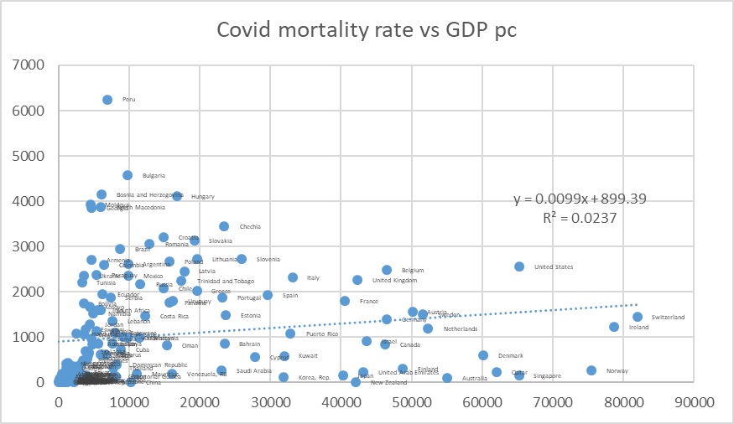

IllustrationtwoAccumulated mortality 2020-2021 per million due to Covid vs median age, by country
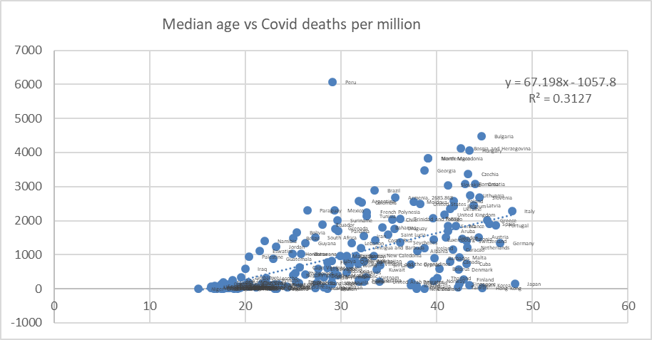

Illustration3Vaccines against Covid per 100 inhabitants vs. GDP pc, by country
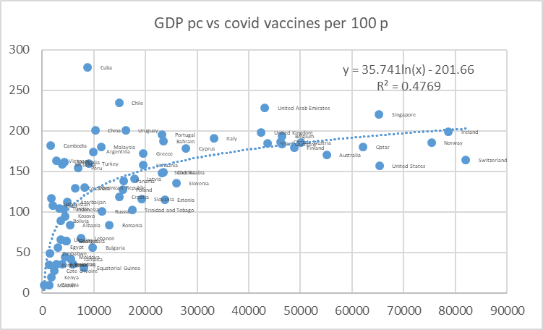

conclusions

Although the actual incidence (most likely underestimated) or lethality (most likely overestimated) of the present pandemic caused by the Covid-19 coronavirus is not known (partly due to the absence of population seroprevalence studies), it can be estimate that it has meant during 2020 (without vaccination) and 2021 (with availability of vaccines even with highly inequitable access) a loss of some 32,580,000 years of life in the world population. Said loss (burden of disease without taking into account the effects of disability) represents 1.96% of the loss of years of life due to all diseases, although recent studies suggest that direct mortality from the virus is 40% of the reported (comorbidity with PCR present), so the real proportion of years of life lost due to the pandemic would be 0.76% of the total. In relation to the risks that cause greater loss of years of life, the pandemic has caused less than 10% loss of years of life caused by the effect of tobacco, agribusiness diets (in both cases with huge marketing financing for consumption) or a sedentary lifestyle, the latter accentuated by the general confinement measures imposed during the pandemic. The evolution of the pandemic, in countries with high and low vaccination coverage, seems to indicate that natural and induced immunity together with mutations that are more adapted to humans, as has occurred with previous coronavirus pandemics, suggest that the virus It is adapting and decreasing its human morbidity and mortality. The pandemic has meant less than 10% loss of years of life caused by the effect of tobacco, agribusiness diets (in both cases with huge marketing funding for their consumption) or a sedentary lifestyle, the last accentuated by the measures of widespread confinement imposed during the pandemic. The evolution of the pandemic, in countries with high and low vaccination coverage, seems to indicate that natural and induced immunity together with mutations that are more adapted to humans, as has occurred with previous coronavirus pandemics, suggest that the virus It is adapting and decreasing its human morbidity and mortality. The pandemic has meant less than 10% loss of years of life caused by the effect of tobacco, agribusiness diets (in both cases with huge marketing funding for their consumption) or a sedentary lifestyle, the last accentuated by the measures of widespread confinement imposed during the pandemic. The evolution of the pandemic, in countries with high and low vaccination coverage, seems to indicate that natural and induced immunity together with mutations that are more adapted to humans, as has occurred with previous coronavirus pandemics, suggest that the virus It is adapting and decreasing its human morbidity and mortality. the last accentuated by the general confinement measures imposed during the pandemic. The evolution of the pandemic, in countries with high and low vaccination coverage, seems to indicate that natural and induced immunity together with mutations that are more adapted to humans, as has occurred with previous coronavirus pandemics, suggest that the virus It is adapting and decreasing its human morbidity and mortality. the last accentuated by the general confinement measures imposed during the pandemic. The evolution of the pandemic, in countries with high and low vaccination coverage, seems to indicate that natural and induced immunity together with mutations that are more adapted to humans, as has occurred with previous coronavirus pandemics, suggest that the virus It is adapting and decreasing its human morbidity and mortality.

As for the measures taken against the pandemic at the global level and at the national and sub-national levels, these have entailed an unprecedented cost or economic loss in the history of public health, which deserves to be studied without prejudice or ideological, economic or politicians. The risk-benefit of confinement and vaccination has not been studied in depth, disaggregating by age groups, general immunity status and against Covid (due to the ignored population sero-prevalence) and risk factors, while the side effects of confinement in the short, medium and long term in physical, mental and social health and indirectly due to the economic contraction, ynide vaccination, without sufficient evidence in the medium and long term of its safety-absence of adverse effects, especially given the unknown of the long-term interaction of mRNA vaccines with the human genome. On the other hand, the utility cost of the measures taken has been up to $87,210 per year of life protected by confinement, taking into account the economic impact and without taking into account the physical, mental and social effects that have yet to be evaluated, of $23,620 for the vaccination and $5,538 for treatment of severe cases, far from the cost-utility thresholds recommended by the WHO and the World Bank (and the influence of the latter due to conditional loans) for low-income ($150 per DALY) and middle-income countries ($500 per DALY), and even higher, in the case of confinement, than those recommended in public systems and even private insurance systems in high-income countries.

The impact of the pandemic and the measures taken on global equity suggests that although there is no greater impact on low-income countries (discriminated against in the right to health as described above) by the pandemic itself, the effects of The economic contraction will very likely increase global economic inequality and with it health inequity, and vaccination coverage, biased towards middle- and high-income countries, has led to an unfair and preventable excess of 2,056,462 deaths in countries with no average income. low and low, to date.

Parallels with the global reaction to the AIDS pandemic

What the world has experienced with the Covid-19 pandemic, which could be waning due to sustained natural immunity, is very reminiscent of what happened thirty years ago with the global spread of AIDS:

- Systems were not established, nor were attitudes promoted to know the individual and collective serological status in order to better understand its epidemiological dynamics and direct public health and individual responsibility actions: while for AIDS, seropositives should have maximized their prevention of infection to seronegatives (fundamentally through the use of condoms, hindered by the Catholic Church and by the United States government through its PEPFAR program), in the case of COVID-19, seronegatives would be transmission protection cases while seropositives they could have avoided such an extreme degree of economic contraction, strengthened social services for the elderly and people at risk,and quite possibly to have contained the progression of the pandemic by herd immunity.
- There was neither then nor now a global financing system for research of global public goods against the pandemic, that is, universal access to effective and safe diagnostic tests, treatments and vaccines. In the case of AIDS, from the knowledge in 1998 of antiretroviral combination therapies that prevented death, until the establishment of the patent pool in 2004, some two million people died each year, while the corporations that shielded by patents unaffordable prices for the treatment, and life, were enriched with more than $20 billion in benefits ($1,600 per preventable death) even after recovering research investments (largely originally financed by public systems).

recommendations

- Global redistribution of economic resources towards global economic equity that can prevent more than 10 million wrongful deaths a year.
- Promotion of healthy lifestyles correlated with sustainable ecological and carbon footprints for the new generations) and the prevention of more than two million deaths per year due to the effects of climate change).
- Global equity financing of a fund for research and production of public goods with global access, outlawing patents on knowledge and vital goods (oxygen, water, natural foods, essential medicines).
- Access to serological tests on a monthly basis that make it possible to define people and risk groups and their moral and legal responsibility to avoid infecting other people, especially higher risk groups (over 60 years of age and with risk factors).
- Global access to effective and safe vaccines (support for pre-qualification processes for Cuban vaccines and Cobervax) with priority for people over 60 years of age and with risk factors.
- Assess vaccination in other age groups in relation to risk-benefit and cost-utility and cost-opportunity in relation to other global health challenges.

All this must be based on an open and uncensored debate, based on evidence, based on the universal right to health and the ethical principle of equity.

https://www.thelancet.com/journals/lancet/article/PIIS0140-6736(20)31145-4/fulltext
https://www.ncbi.nlm.nih.gov/pmc/articles/PMC8722628/
https://www.ncbi.nlm.nih.gov/pmc/articles/PMC7584920/
https://www.thelancet.com/journals/langlo/article/PIIS2214-109X(20)30544-1/fulltext
https://www.ajtmh.org/view/journals/tpmd/104/6/article-p2176.xml
https://www.pnas.org/content/118/21/e2105968118
https://www.england.nhs.uk/statistics/statistical-work-areas/covid-19-hospital-activity/
https://www.who.int/data/gho/indicator-metadata-registry/imr-details/159
https://www.worldometers.info/coronavirus/coronavirus-age-sex-demographics/
https://www.healthdata.org/gbd/2019
https://elpais.com/sociedad/2022-01-14/los-datos-de-hospitalizados-con-el-coronavirus-incluyen-hasta-un-40-de-pacientes-ingresados-por-otras-dilencias. html
https://www.cebm.net/covid-19/masking-lack-of-evidence-with-politics/
https://www.ncbi.nlm.nih.gov/pmc/articles/PMC8685753/
https://journals.plos.org/plosone/article?id=10.1371/journal.pone.0255251
https://www.healthdata.org/covid/covid-19-vaccine-efficacy-summary
https://www.nejm.org/doi/full/10.1056/nejmoa2114228
https://www.thelancet.com/journals/laninf/article/PIIS1473-3099(21)00690-3/fulltext
Turner, JS, Kim, W., Kalaidina, E. et al. SARS-CoV-2 infection induces long-lived bone marrow plasma cells in humans. Nature 2021
https://www.bmj.com/content/374/bmj.n2101/rr-0
https://www.healthdata.org/covid/video/insights-ihmes-latest-covid-19-model-run
https://www.transparency.org/en/press/covid-19-vaccines-lack-of-transparency-trials-secretive-contracts-science-by-press-release-risk-success-of-global-response
https://www.oxfam.org/en/press-releases/pfizer-biontech-and-moderna-making-1000-profit-every-second-while-worlds-poorest
https://www.bmj.com/content/373/bmj.n1372/rr-2
https://pubmed.ncbi.nlm.nih.gov/34614329/
https://www.pnas.org/content/118/21/e2105968118
https://www.ncbi.nlm.nih.gov/pmc/articles/PMC4065878/
https://www.ncbi.nlm.nih.gov/pmc/articles/PMC6212953/
https://www.ncbi.nlm.nih.gov/pmc/articles/PMC523272/
https://www.science.org/doi/10.1126/science.abj8222
https://pubmed.ncbi.nlm.nih.gov/33889343/
https://www.pfizer.com/news/press-release/press-release-detail/pfizer-announces-additional-phase-23-study-results
https://www.precisionvaccinations.com/2021/11/18/pfizers-covid-19-oral-antiviral-cost-529-course
https://data.worldbank.org/indicator/NY.GDP.MKTP.KD.ZG
https://pubmed.ncbi.nlm.nih.gov/32812212/
https://www.gov.uk/guidance/cost-utility-analysis-health-economic-studies
https://www.sciencedirect.com/science/article/pii/S1098301519301482

